________________________________________________________________________
Jerusalem
November 11, 2020
358/2020

The Population of Ethiopian Origin in Israel
Selected Data Published on the Occasion of the Sigd Festival
At the end of 2019, the population of Ethiopian origin in Israel numbered 155,300 residents. Approximately 87,500 were born in Ethiopia, and 67,800 were Israeli-born with fathers born in Ethiopia.
In 2019, 818 immigrants arrived in Israel from Ethiopia.
Approximately 63% of the population of Ethiopian origin lives in two main districts: about 38% live in the Central District and about 25% live in the Southern District. At the end of 2019, the urban locality with the largest population of Ethiopian origin was Netanya (approximately 12,000 persons). However, the highest percentage of residents of Ethiopian origin out of the total population in a locality was found in Qiryat Mal’akhi (16.0%).
Live births: In 2019, 3,950 infants were born to women of Ethiopian origin in Israel. That year, the average number of children that a woman of Ethiopian origin is expected to bear during her lifetime was 2.92.
During the 2018/19 academic year, 31,890 students of Ethiopian origin – 2.4% of the total population of students in the Hebrew education system – were enrolled in primary and secondary schools.
The percentage of 12th-grade students of Ethiopian origin taking matriculation exams was 92% in 2019, compared with 95.1% of the students in the Hebrew education system overall.
The percentage of those eligible for a matriculation certificate that meets university entrance requirements has been rising in recent years.
The number of students of Ethiopian origin in institutions of higher education has been increasing in recent years: from 2,372 in 2011/12 to 3,546 in 2019/20.
The percentage of first degree students of Ethiopian origin who went on to study towards a first degree in academic colleges was higher than their percentage out of all students in Hebrew education (51.0% compared with 40.4%, respectively).
There were 2,101 active athletes of Ethiopian origin in 2018/19, approximately 1.7% of the total number of active athletes.
Net money income per household among persons of Ethiopian origin was NIS 14,027, compared with NIS 17,276 among households in the overall population, whereas money expenditure was NIS 9,303, compared to NIS 13,324 in the overall population.

Population
At the end of 2019, the population of Ethiopian origin in Israel numbered 155,300 residents. Approximately 87,500 (56%) were born in Ethiopia, and 67,800 (approximately 44%) were persons born in Israel whose fathers were born in Ethiopia.

Immigration from Ethiopia
Approximately one-third of the immigrants from Ethiopia arrived in two major waves: the first in the 1980s (Operation Moses) and the second in 1991 (Operation Solomon). Immigration from Ethiopia has declined in recent years.
In 2019, 818 immigrants arrived in Israel from Ethiopia. In 2018, 208 immigrants arrived from Ethiopia, and 1,467 arrived in 2017.
Diagram 1 - Immigrants from Ethiopia, 1984–2019, Absolute Numbers
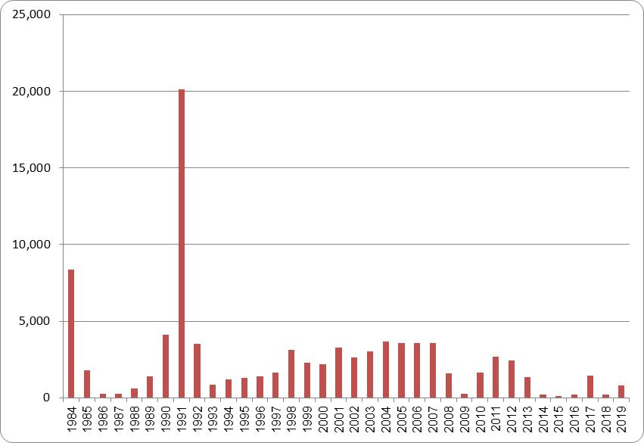

Age Composition
At the end of 2019, children of Ethiopian origin between the ages of 0 to 14 comprised 26.7% of that population (of whom approximately 90.0% were born in Israel). The percentage of persons aged 65 and over among the population of Ethiopian origin was 6.4% (most of whom were born abroad).
By way of comparison, the proportion of persons aged 0 to 14 among the overall population of Jews and Others that year was identical to that of the population of Ethiopian origin: 27.1%. The proportion of persons aged 65 and over among the population of Jews and Others was 13.8%, more than twice their proportion of the population of persons of Ethiopian origin.
Diagram 2 - The Population of Persons of Ethiopian Origin,
by Age and Sex, at the End of 2019, Absolute Numbers
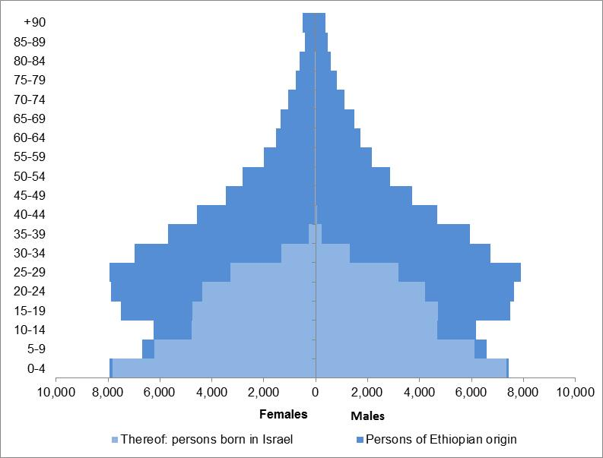

Geographic Distribution
Of the population of Ethiopian origin, 45% live in the centre of the country: 59,000 persons (38.1%) live in the Central District and approximately 10,000 persons (6.7%) live in the Tel Aviv District. Approximately one-quarter of the population (39,000 persons) lives in the Southern District.
Diagram 3 - The Population of Ethiopian Origin by District, 2019 (Percentages)
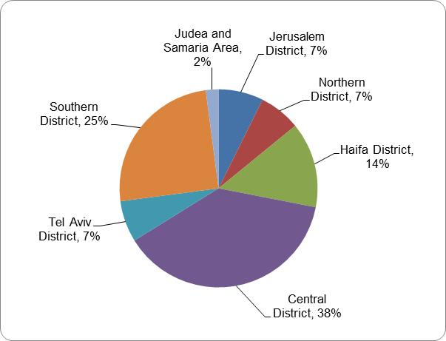
At the end of 2019, the urban locality with the highest number of residents of Ethiopian origin was Netanya (12,000 persons). The locality with the highest percentage of residents of Ethiopian origin, of the locality’s overall population, was Qiryat Mal’akhi (16.0%). In comparison, less than 2% of the total population of Israel was of Ethiopian origin.
Table A - The Population of Ethiopian Origin at the End of 2019, in Main Localities (1)
Locality | Total population in locality (thousands) | Total Population of Ethiopian origin in locality (thousands) | Percentage population of Ethiopian origin out of total population in locality
National Total | 9,140.5 | 155.3 | 1.7
Netanya | 221.4 | 12.0 | 5.4
Rishon LeZiyyon | 254.4 | 8.9 | 3.5
Be’er Sheva | 209.7 | 8.7 | 4.1
Petah Tiqwa | 248.0 | 8.1 | 3.2
Ashqelon | 144.1 | 7.7 | 5.3
Rehovot | 143.9 | 7.6 | 5.3
Ashdod | 225.9 | 7.4 | 3.3
Jerusalem | 936.4 | 6.4 | 0.7
Hadera | 97.3 | 5.9 | 6.1
Qiryat Gat | 57.1 | 5.8 | 10.2
Haifa | 285.3 | 5.8 | 2.0
Bet Shemesh | 125.0 | 4.3 | 3.5
Ramla | 76.2 | 4.2 | 5.6
Lod | 77.2 | 4.2 | 5.4
Qiryat Mal’akhi | 23.8 | 3.8 | 16.0
Afula | 54.2 | 3.8 | 7.0
Yavne | 47.6 | 3.4 | 7.2
Tel Aviv-Yafo | 460.6 | 2.7 | 0.6
Bat Yam | 129.0 | 2.6 | 2.0
Holon | 196.3 | 2.4 | 1.2
- Localities with 2,000 or more residents of Ethiopian origin
In some of the localities, the communities consisting of residents of Ethiopian origin are concentrated in specific neighbourhoods. Thus, for example, approximately 3,100 persons of Ethiopian origin reside in the Qiryat Moshe (North) neighbourhood of the city of Rehovot, comprising over 56% of the total number of residents in the neighborhood. In the Ramat Eliyahu (North) neighbourhood of Rishon LeZiyyon, there are 2,700 residents of Ethiopian origin, comprising 52% of the total number of residents in the neighborhood.
Table B - Neighbourhoods With One-Third or More
Residents of Ethiopian Origin, End of 2019 (1)
Name of locality and neighbourhood | Total population of neighbourhood (thousands) | Total population of Ethiopian origin in neighbourhood (thousands) | Percentage population of Ethiopian origin out of total neighbourhood population
Qiryat Gat  Paz | 0.5 | 0.3 | 56.5
Rehovot  Qiryat Moshe (North) | 5.4 | 3.1 | 56.4
Rishon LeZiyyon  Ramat Eliyahu (North) | 5.1 | 2.7 | 52.3
Bet Shemesh  Qiryat Ben Eli’ezer;  Ganne Shemesh | 1.1 | 0.4 | 39.0
Netanya  Ne’ot Shaked (Azorim) East | 5.0 | 1.9 | 38.5
Qiryat Mal’akhi  Herzl; Weizmann; Newe Or | 5.0 | 1.9 | 37.1
- Localities with 2,000 or more residents of Ethiopian origin

Marriages and Divorces in 2018
During 2018, 793 grooms and 867 brides of Ethiopian origin were married in Israel in licenced religious institutions, 91% for the first time.
Table C - Marriages of Persons of Ethiopian Origin in 2018
Absolute numbers | Grooms | Brides
Total number of persons of Ethiopian origin marrying | 793 | 867
Born in Ethiopia – total | 626 | 608
Thereof: Immigrated through 1990 | 107 | 85
Immigrated after 1990 | 519 | 523
Israeli-born, father born in Ethiopia | 167 | 259
Of persons of Ethiopian origin who married, 87% married a spouse of the same origin. The percentage of men who married a spouse of the same origin (91%) was higher than the percentage of women who did so (83%). Members of the population of Ethiopian origin tended to marry at a later age than members of the overall Jewish population did. Among men of Ethiopian origin, the average age at first marriage was 29.7 in 2018 (2.2 years older than the median age of Jewish grooms). Among women of Ethiopian origin, the average age at first marriage was 27.6 (1.9 years older than Jewish brides).
In 2018, 349 men and 365 women of Ethiopian origin divorced.
The divorce rate among the population of Ethiopian origin was higher than the divorce rate in the overall Jewish population. Approximately 16 of every 1,000 married couples divorced, compared with 9 of every 1,000 married couples in the overall Jewish population.

Live Births
In 2019, 3,950 infants were born to women of Ethiopian origin. Approximately 82% of these women were born in Ethiopia.
That year, the average number of children an Ethiopian woman was expected to bear during her lifetime was 2.92, as opposed to 2.97 in the Jews and Others population.
In 2019, the age at first birth among women of Ethiopian origin was 28.5 years on average, compared to 28.7 years on average among Jewish and Other women.
The share of births to never-married mothers of Ethiopian origin – 13.7% – was over twice as high as the share of births to never-married mothers in the Jewish and Other group – 6.5%. The average age of never-married Ethiopian mothers bearing their first child was younger than that of Jewish and Other mothers – 27.4 versus 32.2, respectively.

Ethiopian Households

Households
The average number of households consisting of persons of Ethiopian origin in Israel in 2017–2019 was 38,200, accounting for approximately 1.4% of all Israeli households and approximately 1.7% of the households of Jews and Others, similar to previous years.
As in the overall Jewish population, approximately 83% of the households of Ethiopian origin were family households. Of those, approximately 93% consisted of only one family. However, the relative proportion of households of one family with others or two or more families was slightly higher in households of Ethiopian origin than it was among Jewish and Other households (about 7% and 4%, respectively). The average size of households of Ethiopian origin was 3.82 persons – larger than the size of households of Jews and Others (3.03).
Approximately 17% of the households of persons of Ethiopian origin were non-family households, and most of them (about 87%) consisted of one person who lived alone.

Families
In Israel, there are approximately 32,400 families of Ethiopian origin. More than half have a traditional structure, consisting of a couple with children of all ages (approximately 61%). This percentage is similar to that of families of Jews and Others (57%).
The percentage of couples without children among families of Ethiopian origin was the lowest (approximately 12%): lower than the percentage among families of Jews and Others (approximately 29%). It should be noted that the couples of Ethiopian origin without children are relatively young, so they may not have had children yet. This is in comparison to couples without children in families of Jews and Others, which include older couples whose children have left home.
The percentage of lone-parent families in the population of Ethiopian origin was especially high (approximately 25%) – more than twice as high as the percentage of lone-parent families among families of Jews and Others (approximately 13%).
Diagram 4 - Families, by Type of Family, 2019
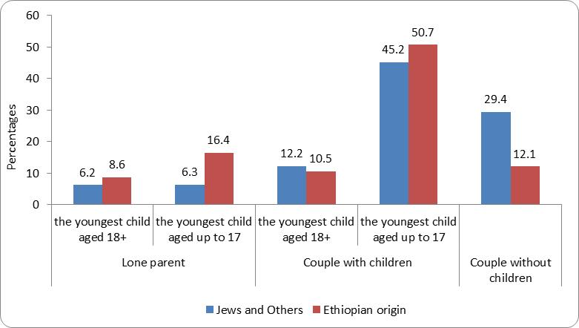

Students in the Education System
In the 2018/19 school year, 31,890 students of Ethiopian origin were enrolled in primary and secondary education, comprising 2.4% of all students in the Hebrew education sector.
In the 2018/19 school year, 23.9% of the students of Ethiopian origin were born in Ethiopia, compared to 42.0% in the 2008/09 school year (Diagram 5).
Diagram 5 - Students of Ethiopian Origin, by Place of Birth, Selected Years
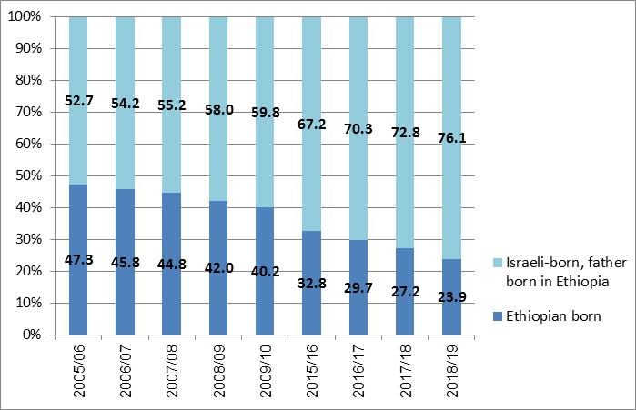
In the 2018/19 school year, about 42.9% of the students of Ethiopian origin were enrolled in schools under State-religious supervision (primary and secondary education). This percentage has been declining over the past decade (it was 55.4% in the 2008/09 school year). Concomitantly, there has been an increase in the percentage of students enrolled in schools under State supervision (52.2%, compared to 42.3% in the 2008/09 school year). In Ultra-Orthodox supervision, this figure rose to 4.9% – more than twice the percentage in the 2008/09 school year (2.3%) (Diagram 6).
Diagram 6 - Students of Ethiopian Origin, by Supervision, Selected Years
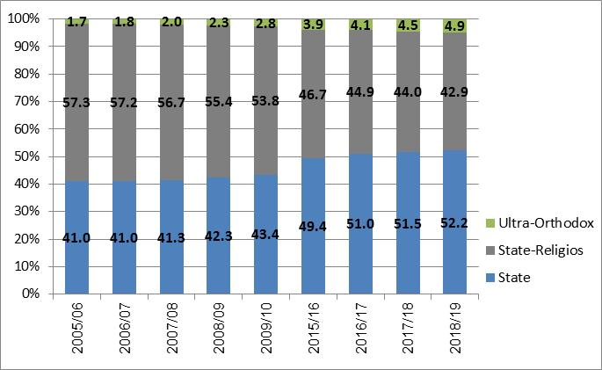
In the primary education system in 2018/19, 6.2% of Ethiopian-born students and 8.9% of Israeli-born students whose fathers were born in Ethiopia studied under Ultra-Orthodox supervision. Over the past decade, there has been a decline in the proportion of students under State-religious supervision in both groups of students (students born in Ethiopia and those born in Israel whose fathers were born in Ethiopia), concomitant with an increase in the proportion of students under State supervision and Ultra-Orthodox supervision (Diagram 7).

Diagram 7 - Students of Ethiopian Origin, by Place of Birth and Supervision
(Primary Education), Selected Years
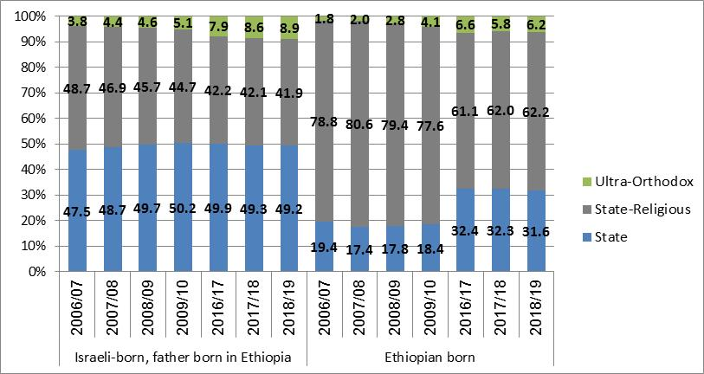
Among students of Ethiopian origin in upper secondary education, 49.2% were enrolled in the technological/vocational track, whereas 34.7% of their non-Ethiopian counterparts in Hebrew education were enrolled in the technological / vocational track
Diagram 8 - Students Attending Technological/Vocational Courses (Hebrew Education), By Origin and Sex, 2018/19
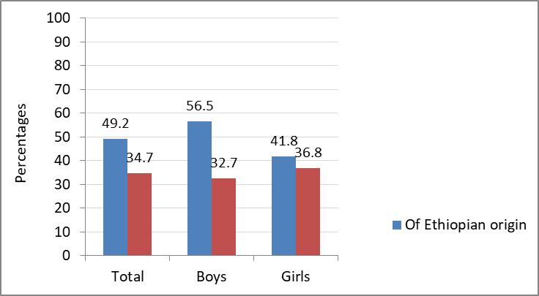

Matriculation Examinees
In the 2018/19 school year, 2,613 12th grade students of Ethiopian origin took matriculation exams.
The percentage of 12th grade students of Ethiopian origin taking matriculation exams was 92% in 2019, compared with 95.1% of the overall Hebrew education sector (excluding ultra-Orthodox supervision). The percentage of students of Ethiopian origin who were eligible for a matriculation certificate is significantly lower – 64.3% versus 80.5%, respectively. However, the percentage of students of Ethiopian origin who are eligible for a matriculation certificate has been rising in recent years, with a slight decrease over the past year (see Diagram 9).
The share of students of Ethiopian origin holding a matriculation certificate that met university entrance requirements (i.e., the percentage of potential candidates for continued study at institutions of higher education) was 44.8%, compared with two-thirds (71.4%) of the total number of students in the Hebrew education sector. It should be noted, however, that percentage of students eligible for a matriculation certificate that meets university entrance requirements has been increasing in recent years (see Diagram 9).

Diagram 9 - 12th-Grade Students of Ethiopian Origin
Who Took the Matriculation Exams
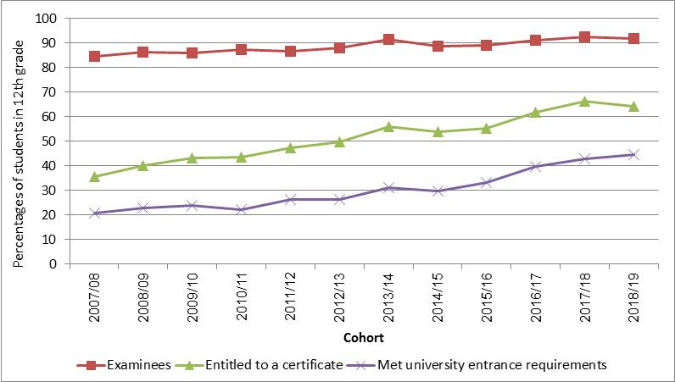
The percentage of those entitled to a matriculation certificate among students of Ethiopian origin who studied in institutions with State-religious supervision was 70.9%, compared with 59.7% among those who studied in institutions under State supervision. Moreover, 51.4% of those under State supervision met university entrance requirements, compared with 40.1% of those under State-religious supervision.
In 2018/19, the share of the second-generation students of Ethiopian origin (those born in Israel whose fathers were born in Ethiopia) was 61.2% of all 12th grade students of Ethiopian origin. The percentages of 12th-grade students of Ethiopian origin who were entitled to a matriculation certificate were 65.5% of those born in Ethiopia and 63.4% among second-generation students of Ethiopian origin. The percentage of those who met university entrance requirements was higher among the second generation – 46.8% – compared with 41.6% among those born in Ethiopia.

Students of Ethiopian Origin in Pre-Academic Preparatory Programs (2017/18)
In the 2017/18 academic year, 721 students of Ethiopian origin were enrolled in pre-academic programs – 75.7% women and 24.3% men. There were 281 students (39%) in the designated track, 417 students (57.8%) in the track to complete matriculation and improve matriculation scores, 19 students (2.6%) in the track to prepare for the pre-academic preparatory program; and 4 students (0.6%) in the track to complete 12 years of schooling.

Continuation of Studies Towards a First Degree in 2010/11 within Eight Years of Graduating High School Among Secondary School Graduates of Ethiopian Origin (Tracking Until 2018/19)
Only 21.7% of secondary-school graduates of Ethiopian origin went on to study for a first degree within eight years of completing secondary school, compared with 47.2% of all secondary school graduates in Hebrew education.
The percentage of Israeli-born students of Ethiopian origin (with at least one parent who was born in Ethiopia) was slightly higher than the percentage of Ethiopian-born students (22.8% versus 20.3%, respectively).
The percentage of students of Ethiopian origin who attended universities, out of the total number of persons of Ethiopian origin who went on to study for a first degree, was lower than the percentage of the total number of students in the Hebrew education sector who went on to study for a first degree at universities (26.5% versus 35.8%, respectively). By contrast, the percentage of those who went on to study for a first degree at academic colleges was higher among persons of Ethiopian origin than the percentage of all students in the Hebrew education sector (51.0% versus 40.4%, respectively).

Table D - Continuation of Studies Towards a First Degree Among Secondary School Graduates of Ethiopian Origin Among All Secondary School Graduates of Ethiopian Origin and Among All Secondary School Graduates in 2010/11 Within Eight Years of Secondary School Graduation, By Type of Higher Education Institution
- | Hebrew education – total | All persons of Ethiopian origin | Ethiopian-born | Israeli-born persons of Ethiopian origin
Total number of secondary school students who completed Grade 12 (absolute numbers) | 76,569 | 2,921 | 1,307 | 1,614
Thereof: Students who went on to academic studies - percentages | 47.2 | 21.7 | 20.3 | 22.8
- absolute numbers | 36,105 | 633 | 265 | 368
Students who went on to academic studies, by type of institution  Percentages | 100.0 | 100.0 | 100.0 | 100.0
Universities | 35.8 | 26.5 | 19.6 | 31.5
The Open University | 11.7 | 10 | 8.7 | 10.9
Academic colleges | 40.4 | 51 | 57 | 46.7
Academic colleges of education | 12.1 | 12.5 | 14.7 | 10.9

Higher Education

Students
The number of students of Ethiopian origin studying at institutions of higher education has been increasing in recent years: from 2,372 in 2011/12 to 3,546 in 2019/20. The percentage of students of Ethiopian origin of the overall number of students also increased during those years – from 0.9% to 1.3%. Despite what was stated above, the relative chances of Ethiopian immigrants to enter higher education are still 0.7 times lower than those of native-born Israelis. The chances of men of Ethiopian origin to enter higher education are particularly low, at half the chances of native-born Israeli men.
Diagram 10 - Students of Ethiopian Origin in Institutions of Higher Education, Absolute Numbers and Percentage of Total Students
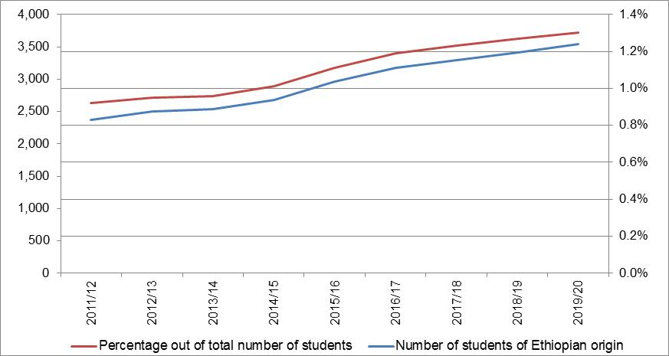

First Degree Studies
In 2019/20, 3,018 students of Ethiopian origin (1.5% of all students) studied towards a first degree. High percentages of students of Ethiopian origin were enrolled in the following fields: business and management sciences (2.8%), paramedical professions (2.2%), and social sciences (2.0%, excluding business and management sciences). Low percentages were enrolled in the following fields: medicine (0.4%), and natural sciences, mathematics, and agriculture (0.6%). In that year, students of Ethiopian origin attended mainly the academic colleges (59.7% compared with 48.0% of all students), fewer attended universities (27.6% versus 38.6% of all students), and 12.7% attended academic colleges of education (compared with 13.4% of all students).

Second and Third Degree Studies
In 2019/20, 452 students of Ethiopian origin studied towards a second degree, and 21 studied towards a third degree. The percentages of students of Ethiopian origin were low among second degree students (0.8%) and third degree students (0.2%). The main fields studied by students of Ethiopian origin in the second degree programs were business and management sciences (29.4%), humanities (25.0%), and social sciences (24.8%, excluding business and management sciences).
In natural sciences, and in mathematics and agriculture as well as in engineering and architecture, there were few students of Ethiopian origin – 4.4% and 4.0% out of all students of Ethiopian origin, respectively. However, enrollment in these fields was higher among the total number of students (10.1% and 6.5%, respectively).

Active Athletes
In 2018/19, there were 2,101 active athletes of Ethiopian origin, 1.7% of the population of active athletes. By comparison, the percentage of students of Ethiopian origin that year out of the total population of Jews and Others in that age group was 1.9%.
In 2017/18, there were 1,781 active athletes of Ethiopian origin, comprising roughly 1.9% of the total number of active athletes.
Women comprised 10.9% of active athletes of Ethiopian origin. This was a higher percentage than the previous year – 9.0% – but still less than the percentage of women among the active athletes in the overall population – 23.7%.
An examination by age shows that 64.1% of the active athletes of Ethiopian origin range from 12 to 17 years of age, whereas 25.1% are 18 to 24 years of age. The percentage of active athletes in the remaining age groups is lower than 10%.
Diagram 11 - Percentage of Active Athletes of Ethiopian Origin of Total Number of Active Athletes, by Age (2018/19)
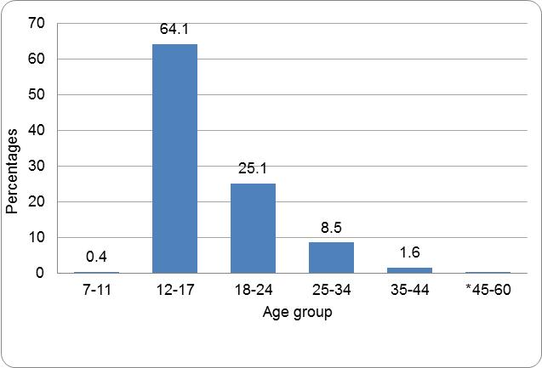
Of the total number of athletes of Ethiopian origin, 84.6% train in team sports, and the rest (15.4%) in individual sports.
The most prevalent sports among athletes of Ethiopian origin are:
Football: 1,561 athletes, who comprise 4.6% of the total number of athletes in the sport – a percentage similar to that of the previous year (4.4%)
Basketball: 159 athletes, who comprise 0.6% of the total number of athletes in the sport – a percentage similar to that of the previous year (0.5%)
Athletics: 89 athletes, who comprise about 4.5% of the total number of athletes in the sport – a lower percentage than that of the previous year (5.0%)
The vast majority of athletes of Ethiopian origin (74.3%) play football, compared with 27.7% of the total number of active athletes who play soccer.

Persons Registered at the Ministry of Labor, Social Affairs and Social Services and persons Defined as Needing Intervention
Approximately 30,000 immigrants of Ethiopian origin (a rate of about 341 per 1,000 persons) were registered at the Ministry of Labor, Social Affairs and Social Services in 2019 (compared with a rate of about 376 per 1,000 persons in 2018). That is, one out of three Ethiopian-born persons was registered at social services departments. This percentage is 2.5 times higher than the registration rate of Jews and Others among persons born abroad, which was about 134 per 1,000 persons. Of the Ethiopian-born persons who were registered, approximately 80% were defined as needing intervention. They numbered about 24,000 persons, and their rate was approximately 273 per 1,000 persons (compared with about 309 per 1,000 persons in 2018).
Approximately 19,500 persons born in Israel whose fathers were born in Ethiopia (hereinafter: the second generation) were registered, a rate of about 288 per 1,000 persons (compared with about 309 per 1,000 persons in 2018). This percentage is three times the percentage of Israeli-born persons who are registered (about 96 per 1,000 persons). Only 40% of those registered were defined as needing intervention. Their number was about 8,000, and their rate was about 115 per 1,000 persons.
In 2019, the most often cited reason for needing intervention among Ethiopian-born persons and among the second generation who were defined as needing intervention was dysfunctional parents and/or children/adolescents (approximately 43%). The second most prevalent reason for needing intervention was poverty, income and employment problems (approximately 27%). The least common reason for needing intervention was addiction and delinquency (approximately 2%).
Diagram 12 - Type of Need for Intervention among Ethiopian-born persons and the Second Generation of Ethiopian-born Persons Who Needed Intervention, 2019
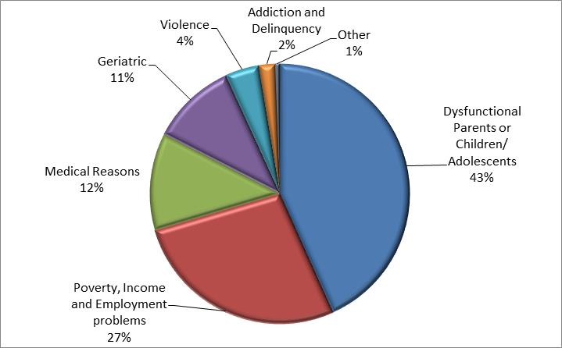
Recipients of Welfare Services in Community and Out-of-Home Frameworks of the Ministry of Labor, Social Affairs and Social Services
In 2019, approximately 4,700 Ethiopian-born persons (about 53 per 1,000 persons), and approximately 5,500 persons of the second generation (about 81 per 1,000 persons) were placed in settings of the Ministry of Labor, Social Affairs and Social Services.

Among Ethiopian-born persons:
The rate of persons placed in out-of-home frameworks only was about 5 per 1,000 persons.
The rate of persons placed in community frameworks only was about 47 per 1,000 persons – twice as high as the overall rate of persons placed in community frameworks only (about 23 per 1,000 persons).
The rate of persons placed in both community and out-of-home frameworks was about 1.6 per 1,000 persons.
Among the second generation of Ethiopian-born persons:
The rate of persons placed in out-of-home frameworks was about 9 per 1,000 persons
The rate of persons placed in community frameworks was about 70 per 1,000 persons. This is three times higher than the total number of persons placed in community settings (about 23 per 1,000 persons).
The rate of persons placed in both community and out-of-home frameworks was about 2 per 1,000 persons.

Persons With Disabilities: Persons Holding a Certificate of Blindness/Visual Impairment and IDF Disabled Veterans
Of the overall number of persons holding a certificate of blindness/visual impairment issued by the Ministry of Labour, Social Affairs, and Social Services, about 2.5% were born in Ethiopia, and their rate is approximately 7 per 1,000 persons. This figure is 2.5 times higher than the general rate among holders of a certificate of blindness/visual impairment, which was 2.7 per 1,000 persons.
Of all the disabled IDF veterans whose disability was recognized after 1986 (after Operation Moses), about one percent were found to have been born in Ethiopia or members of the second generation of persons born in Ethiopia.

Persons of Ethiopian Origin Judged in Criminal Trials
In 2018, 1,257 Jewish and Other residents of Israel of Ethiopian origin were judged in criminal trials (of whom 750 were born in Ethiopia and 507 were born in Israel and their fathers were born in Ethiopia).
The percentage of persons of Ethiopian origin who were judged constituted 7.4% of the total number of residents of Israel in the Jewish and Other population who were judged. The percentage of juvenile immigrants of Ethiopian origin (14.1%) was much higher than that of adults (6.9%).

Diagram 13 - Percentage of Persons of Ethiopian Origin out of Jewish and Other Israeli Residents Who Were Judged in Criminal Trials, by Age of Criminal Responsibility (Year of Verdict 2018)
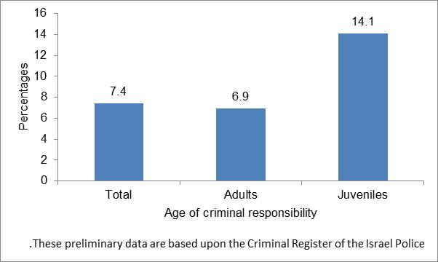
Men comprised 93.6% of the adults of Ethiopian origin who were judged. This percentage was higher than the percentage of men among the total number of adult Jews and Others who were judged: 88.8%.
Among juveniles of Ethiopian origin who were judged, the percentage of boys was 97.8%. By way of comparison, the percentage of boys among the total number of juvenile residents of Israel in the Jews and Others group who were judged was 94.2%.
The percentage of persons convicted among adults of Ethiopian origin who were judged in criminal trials was 86.2%, slightly higher than the percentage of persons convicted among the overall population of residents of Israel in the Jewish and Others group who were judged (85.2%). The percentage of persons convicted among juveniles of Ethiopian origin who were judged (39.7%) was similar to the percentage of juveniles among the Jews and Others group (39.6%).
Among adults of Ethiopian origin who were judged, close to half (45.6%) were charged with offences against the public order, 20.9% were charged with offences involving bodily harm, and 18.2% were charged with property offences.
The most prevalent offences with which juveniles of Ethiopian origin who were judged were charged were property offences (43.5%), offences against the public order (25.0%), and offences involving bodily harm (24.5%).

Data from the 2018 Household Expenditure Survey
The average consumption expenditure per household among the population of Ethiopian origin was NIS 12,084, compared to NIS 16,475 in households in the overall population – 26.7% less than the average in the total population.
Net money income per household among persons of Ethiopian origin was NIS 14,027, compared with NIS 17,276 in all households in the overall population, whereas the money expenditure per household was NIS 9,303, compared to NIS 13,324 in the overall population.
The average number of wage earners per household was 1.9, compared to 1.5 wage earners per household in the overall population.
Table E - Net Money Income and Money Expenditure in Households in the Overall Population and Households of Persons of Ethiopian Origin, 2018
Money Income and Money Expenditure in Households | Households in the overall population | Households of persons of Ethiopian origin
Average number of wage-earners | 1.5 | 1.9
- | NIS | NIS
Gross money income per households | 21,063 | 15,604
Net money income per household | 17,276 | 14,027
Money expenditure per household | 13,324 | 9,303

Table F - Monthly Consumption Expenditure by Main Groups, in Households in the Overall Population and Households of Persons of Ethiopian Origin, 2018
Makeup of Consumption Expenditure | Consumption expenditure in NIS households in the overall population | Makeup of expenditure in percentages in households in the overall population | Consumption expenditure in NIS in households of persons of Ethiopian origin | Makeup of expenditure in percentages in households of persons of Ethiopian origin
Consumption expenditure – total | 16,475 | 100.0 | 12,084 | 100.0
Food (excl. vegetables and fruits) | 2,282 | 13.8 | 1,528 | 12.6
Vegetables and fruits | 556 | 3.4 | 280 | 2.3
Housing | 4,089 | 24.8 | 3,646 | 30.2
Dwelling and household maintenance | 1,498 | 9.1 | 1,239 | 10.3
Furniture and household equipment | 606 | 3.7 | 942 | 7.8
Clothing and footwear | 492 | 3.0 | 471 | 3.9
Health | 984 | 6.0 | 537 | 4.4
Education, culture, and entertainment | 1,798 | 10.9 | 1,234 | 10.2
Transport and communications | 3,356 | 20.4 | 1,732 | 14.3
Miscellaneous goods and services | 815 | 4.9 | 475 | 3.9

The percentages of expenditure of households in the overall population are higher for most items than in households of persons of Ethiopian origin, with the following exceptions: housing (30.2% versus 24.8%, respectively); furniture and household equipment (7.8% versus 3.7%, respectively); clothing and footwear (3.9% versus 3.0%, respectively); and maintenance of dwelling (10.3% versus 9.1%, respectively).
In terms of ownership of communication products, there are differences between households of persons of Ethiopian origin and households in the overall population. Among households of Ethiopian origin, the percentage of ownership of most of the products is low compared with households in the overall population, except for mobile phones: 99.1% (compared with 97.9% in the overall population).
Diagram 14 - Ownership of Communication Products in Households in the Overall Population and in Households of Persons of Ethiopian Origin, 2018
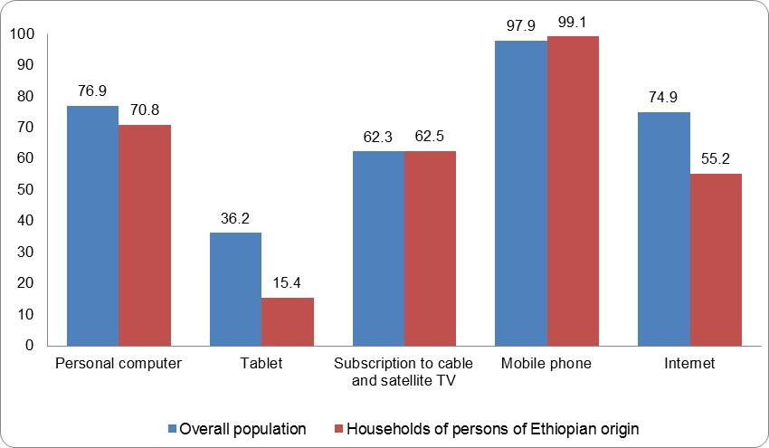
The percentage of ownership of products for the kitchen and the home is also lower in households of persons of Ethiopian origin than in the overall population, except for ownership of a cooking and baking stove and microwave.

Diagram 15 - Ownership of Kitchen Appliances in Households in the Overall Population and in Households of Persons of Ethiopian Origin, 2018
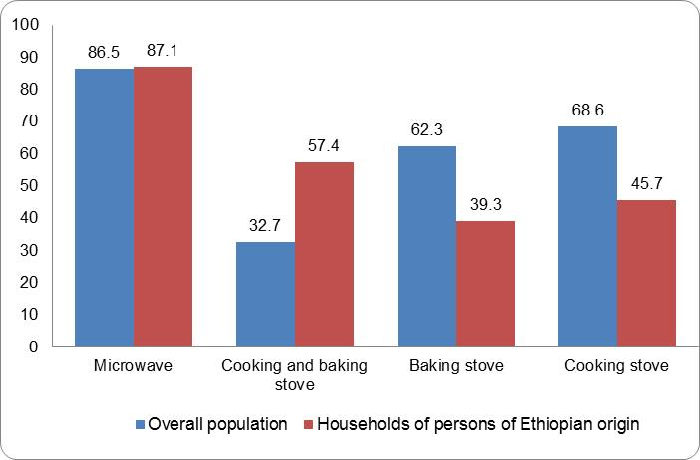

Unless otherwise stated, Ethiopian origin refers to a person born in Ethiopia, or a person born in Israel whose father was born in Ethiopia.
Not including the Open University, which has unique characteristics that distinguish it from the other institutions of higher education in Israel. This is reflected in the policy of open admission to first degree studies (without pre-requisites), the courses of study, as well as the composition of the student population. However, the aim is to include the Open University in the current statistics on higher education institutions while taking the distinctive characteristics of this institution into consideration.
A household in which the head of the household or one of his or her parents was born in Ethiopia.
Money expenditure: consumption expenditure, excluding imputation for housing services.
The neighborhood with the highest percentage of residents of Ethiopian origin out of the total population was the Paz neighborhood in Kiryat Gat (56.5%), but 300 residents of Ethiopian origin live there.
The source of the data is the Population Register. The data do not include marriages performed abroad or alternative marriages of Jews performed in Israel outside of the Orthodox Jewish framework.
The source of data is the Labour Force Survey. The data for the overall population and the population of Jews and Others are for 2019. The data for the population of Ethiopian origin are the average for 2017-2019. The population does not include persons living in institutions, kibbutzim, student dormitories, and those living outside of localities (Bedouins in the south).
A household is defined as one person or a group of persons living together in one dwelling on a permanent basis most of the week, who have a joint expense budget for food. A household can include persons who are not related to each other. A household of persons of Ethiopian origin was defined as a household in which at least one person aged 15 or over is of Ethiopian origin (i.e., Ethiopian-born or whose father was born in Ethiopia).
A family household is a household that contains at least one family. A family household can include: one family, one family with other persons, or two families or more.
A nuclear family of two persons or more who share the same household and are related to one another as husband and wife, as an unmarried couple (incl. same-sex couples), or as parent and child (including an adopted child). Thus, a family can be only a couple, a couple with children (in various age groups, defined by the age of the youngest child), or a lone parent with children (lone parent family). A family also includes a family of grandparents with grandchildren without parents, or only siblings who live together without spouses or children. A family of persons of Ethiopian origin is considered a family if at least one member, aged 15 or over, is of Ethiopian origin, meaning that he or she was born in Ethiopia or that his or her father was born in Ethiopia.
The method for calculating technological/vocational education (known in the past as the technology track) was changed as of 2016/17, and was updated to reflect the current definitions of the Ministry of Education.
In order to allow for a valid comparison between students of Ethiopian origin and all students in Hebrew education, the population of students examined in this section excludes those enrolled in schools under Ultra-Orthodox supervision (students of Ethiopian origin as well as those enrolled in Hebrew education in general).
Ethiopian-born and Israeli-born students (with one or both parents born in Ethiopia).
Not including the Open University, which has unique characteristics that distinguish it from the other institutions of higher education in Israel. This is reflected in the policy of open admission to first degree studies (without pre-requisites), the courses of study, as well as the composition of the student population. However, the aim is to include the Open University in the current statistics on higher education institutions while taking this institution’s distinctive characteristics into consideration.
The numbers include athletes aged 7–80 in both individual and team sports. Two criteria determine whether an athlete is active: participating in a minimum number of competitions and an upper threshold of birth year (both of these are determined for each sport).
The data presented in this section were processed at the CBS on the basis of files of frameworks and names of the Ministry of Labor, Social Affairs and Social Services. The files include data on persons placed in out-of-home welfare frameworks and in community frameworks.
A file is opened for every family or person who applies or referred to social departments, and at least one family member must be defined as needing intervention.
Excluding persons born in Ethiopia.
Need for intervention: The reason an individual applies or is referred to a department of social services. The social worker treating the family lists, for each individual in the treatment file, the primary need for intervention for each individual as well as the family’s primary need for intervention, from a list of 58 needs (including “no need for intervention”). The social worker can also list a secondary need for intervention for an individual or his or her family.
This need for intervention includes problems with the parent-child relationship, dysfunctional mother or father, educational and behavioral problems of children, teenage girls in distress, abandoned children, etc.
The data presented in this section were processed at the CBS on the basis of files of settings and placements of the Ministry of Labour, Social Affairs and Social Services. The files include data on persons who were placed in out-of-home and community settings.
A person who is unable to live with his family due to his own exposure or exposure of his family to situations of distress and risk. Examples of out-of-home placement: foster families, shelters, boarding schools, emergency centers, nursing home.
A person who continues living with his natural family, and who receives community services and support in accordance with the "Looking Towards the Community" policy of the Ministry of Labor, Social Affairs and Social Services. Examples of community settings are: day care centers, after-school child care programs, day care in a home setting, parent and child centers, and centers for the prevention of violence.
A person who has been recognized by the Ministry of Labour, Social Affairs and Social Services as having total lack of vision or as having maximal visual acuity of 3/60 in his/her good eye (after correcting the vision with glasses, surgery, an implant, etc.), or as having a field of vision of up to 20 degrees in the good eye (after correcting the vision with glasses, surgery, an implant, etc.), versus a normal field of vision of 180 degrees. This recognition is expressed by the issuing of a certificate from the service that deals with persons who have blindness at the Ministry of Labour, Social Affairs, and Social Services. Holders of a certificate of Blindness are entitled to rehabilitation services and benefits.
The statistics are based upon the Israel Police’s Criminal Register, and are up to date as of May 2020. The data for the year of verdict 2018 are preliminary.
A household in which the head of the household or one of his or her parents was born in Ethiopia.
As of 2012, the number of earners also includes soldiers in compulsory service.

