______________________________________________________________________________
Jerusalem
August 16, 2021
278/2021
70 Years of Israeli Statistics
in the CBS's Historical Statistical Atlas
- The CBS has just published, for the first time, a unique statistical atlas that includes 70 years of statistics of the State of Israel, from the establishment of the State through its 70th year of independence (1948–2018).
- The Atlas presents the demographic, societal, and economic development of the State of Israel, as well as its development in many other fields.
- The atlas has been published in a limited printed edition and on the CBS website.
- The atlas is available for download as a PDF file from the CBS website. Also, the data used to produce the maps are available for download as Excel files.
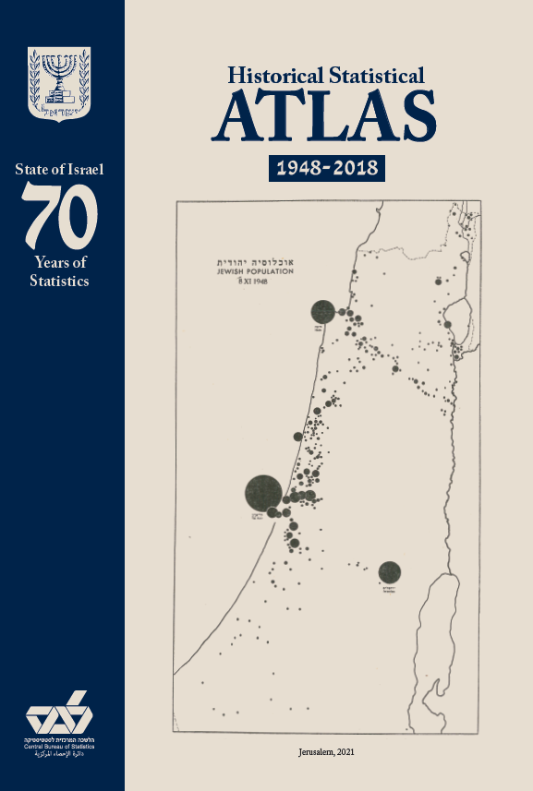

The Central Bureau of Statistics is honored to present to the general public its Historical Statistical Atlas, which includes a large collection of statistical data of interest about the State of Israel. These data were collected by the Central Bureau of Statistics over 70 years, starting with the first census in 1948 and the Statistical Abstract of Israel No. 1, continuing with the population census data over the years, and ending with up-to-date maps from the Statistical Abstract of Israel containing data on the 70th year of the country.

The main goals in producing the Atlas
- Presenting maps with historical statistical data on the State of Israel, based on data from the Central Bureau of Statistics;
- Republishing of statistical maps having historical value;
- Comparing statistical topics of interest among the censuses;
- Presenting an up-to-date snapshot of Israeli society in its 70th year of independence through the use of maps.

Types of maps and figures in the Atlas
- 28 historical maps and 12 historical figures scanned from the originals;
- 6 maps with up-to-date data based on the cartographic structure of original historical maps, displayed next to the original maps;
- 235 maps and 43 figures produced especially for the Atlas in a contemporary design.

The chapters of the Atlas
- Population Registration (1948 Census) – A special topic in the Atlas is the Jewish population of the State in 1948–1949, for which a series of thematic maps based on CBS data are presented for the first time. These describe spatially for the first time the demographic and economic characteristics of the Jewish population at the time of the establishment of the State, before the large waves of immigration that came after the War of Independence.

- Population Censuses in Israel 1961–2008 – The Atlas maps chronologically statistical data dealing with the living conditions and the technological means available to the households in Israel. Each census is mapped separately, and the development of the conditions in Israeli households can be seen.
- Israel in the 70th Year of Independence – 2018 – Along with the 2018 data, the Atlas provides a 70-year overview based on the maps chapter of the Statistical Abstract of Israel.
- Multi-Year Comparisons of Selected Topics are presented in the Atlas, allowing for comparisons over time.

Selected data – then and today
It’s crowded here today, and will become even more so. In 1948, the Jewish population in the State of Israel was about 717,000 residents. In 2020, the population of Israel was more than 9 million. This number is expected to double within 40 years and exceed 18 million in 2060.
The most crowded areas in the country remained the Tel Aviv and Central districts. The Tel Aviv sub-district has been the most densely populated since the establishment of the State, and has this status today as well. In 2018, there were 8,300 people per square kilometer in the Tel Aviv sub-district. In 2035, this number is expected to be 10,800 residents per square kilometer.
Most Israelis are urban. In 1948, 77% of the Jewish population in the country lived in 29 urban localities (localities with 2,000 or more residents). After 70 years, this percentage had risen to 92% of the total population in 258 urban localities. In 1948, there was one large locality with more than 100,000 residents (Tel Aviv-Yafo); in 2018 there were 15 such localities.
The percentage of kibbutzim decreased from 48% of all localities in the country in 1948 to 22% in 2018. The population of the kibbutzim, which was 8% of the total Jewish population in 1948, was only 2% in 2018.

Jerusalem is approaching one million residents. In 1948, the Jewish population in Jerusalem was about 83,000 residents, out of about 717,000 Jewish residents in Israel. One in 8 Israelis resided in Jerusalem. This trend has been maintained to this day – in 2018, one in 9 Israelis was a Jerusalemite. With a population of more than 900,000 residents in 2018, Jerusalem is the largest city in Israel and is expected to be the first city in the country to cross the million residents threshold.
The percentage of Jews in Israel who were born abroad is declining. In 1948, in 17 regions of the country (out of 19) the percentage of Jews born abroad was more than 45%, and in 14 of these regions it was more than 60%. In 2008, in each of the regions, less than 45% were Jews born abroad.
Immigration patterns have changed. Most of the immigration during 1903–1948 was from the European countries, led by Poland, Romania, Germany, and Russia. The increase in the years 1990–2018 was more diverse, and the leading countries were: the USSR (former), Ethiopia, France, and the United States.
Not as young as they used to be ?! Along with the fact that the population of Israel is considered young, the percentage of people aged 65 and over in the various areas of the country has been steadily rising over the years. This trend is noticeable in the areas along the Mediterranean and in the northern valleys.
We are more educated. Data from the censuses show that the percentage of persons with an academic degree has been steadily rising over the years. In 2018, in most regions of the country, the percentage of persons with an academic degree out of those aged 15 and over was at least 15%, whereas in 1972 the percentage in each of the regions was less than 10%. In the 1961 census, this question was not asked at all.

70 years later – maps and meanings
Covered in concrete. Built-up areas account for 64% of the Tel Aviv district. In the Central District (which surrounds the Tel Aviv District), this percentage is 24%, and in the South – only 1.6%. Of the total built-up areas in the country, 66% are residential.
Most of the agriculture is in the Gaza envelope. Of the total agricultural crops in the country, 40% are grown in the areas near the Gaza Strip, from Lakhish to Ashdod. Other significant concentrations of agriculture are found in the Yizre'el Basin, Eastern Lower Galilee, and West Sharon regions.
People in the Sharon spend more money. Similar to large cities such as Haifa, Ramat Gan and Tel Aviv-Yafo, the average monthly expenditure per capita in the cities of the Sharon was among the highest in the country.
Israelis like to vacation in Elat. Elat breaks national records in the number of person-nights in hotels. In 2018, before the Coronavirus outbreak, there were about 7 million person-nights in the city; 90% of them were of Israelis and the rest were of tourists. The trend for the Dead Sea was similar: 75% of the person-nights were of Israelis. In Jerusalem and Tel Aviv-Yafo, in contrast, tourists accounted for about 75% of the person-nights. In Tiberias, Netanya, and Herzliyya, the division between Israelis and tourists was almost equal, with a slight tendency toward tourists.
Hi-tech is at the Center. Most of the startup companies in Israel are concentrated in the Tel Aviv District, followed by the Central District and the Haifa District. The majority of research and development expenditure in the business sector – 65% of all such expenditure in the country – is concentrated in the Tel Aviv and Central districts.
We all know where the traffic jams are, but we still get stuck in them. The roads with the highest traffic counts are in the Gush Dan area, Highway 6, and Highway 1 between Tel Aviv and Jerusalem. These are followed by the western Galilee area and the northern entrance to Be'er Sheva.

Do you live in the Center? Your home is worth more. The cities with the highest average residential dwelling values are in the Sharon and the Center. The five most expensive cities in Israel are (in descending order): Tel Aviv-Yafo, Giv’atayim, Rosh HaAyin, Ramat Gan, and Herzliyya. Jerusalem is in sixth place.

What did we ask? Questions asked by the CBS in the censuses over the years
Shall I put the milk in the fridge? In 1961, we asked the citizens of the country whether they had a refrigerator or an icebox in the kitchen, and whether there was a way to cook in the dwelling. In 1972 we only asked if there was a kitchen in the house, and since then we have not asked this question.
Excuse me, where is the toilet? Questions about toilets have always interested us! In 1961 we asked if the toilet was inside or outside the building and whether there was a flushing mechanism. In the 1972 census, we were still interested in the location of the toilet (inside or outside) and whether it was in the same room as the bathtub or in a separate room. In 1983, we only asked whether there was a toilet in the house, and in the following censuses we already knew where everyone's toilet was located, so we moved on to ask the number of toilets in the dwelling.
The neighbors come to take a shower. From 1961 to 1995, we asked whether there was a bath or shower in the house. In 1961, we asked if the bath and shower were for the family’s use only, or whether the neighbors came to shower as well. Just don’t forget a towel.
Need to turn on the boiler? From the 1961 census on, we checked how the household heated water for the bath and shower, and already then we asked if there was a solar water heater or an electric heater in the household. This question was asked in all the censuses carried out in Israel.
Durable goods for household use. In the censuses, we asked about the presence of durable goods (goods that are used by the household, but not necessarily owned by it). In 1972 we asked if there were a telephone, an air conditioner, an oven, or a TV in the home. By 1983 we asked if the TV was black and white or color, and if there was a dishwasher. By 1995 we advanced to questions about a clothes dryer, microwave, videocassette player, and personal computer, and in 2008, in addition to the rest of the products, we asked questions about a cell phone, an internet connection and computers. In 1972 we began asking if there was at least one car available to use, and in 2008 we asked about two or more cars and about who owns or leases the vehicle. In 1961 we did not even ask if you had a car.

For an explanation of the regions, see the description of how the statistical data are mapped, on page 8 of the Atlas.

