_____________________________________________________________________________________________________________________
Previous Media Release on Foreign Trade appeared on December 20, 2023
Jerusalem,

January 21, 2024

026/2024

Israel’s Foreign Trade in Goods by Country - 2023
Foreign Trade in 2023 compared with 2022
- The countries to which exports of goods (excluding diamonds) from Israel had the largest increases were: Morocco, Egypt, Hungary, Romania, Uruguay, Lithuania, Hong Kong and Poland. In contrast, the countries with the largest decreases were: Malaysia, Albania, Taiwan, France, Turkey, Canada and United Kingdom.
- The countries from which exports of goods (excluding diamonds) to Israel had the largest decreases were: Paraguay, Norway, Russian Federation, Uruguay and Brazil. In contrast, the countries with the largest increases were: Namibia, Zambia, South Africa, Philippines and United Arab Emirates.
- The countries with which Israel had the largest trade surpluses (excluding diamonds) were: USA, Ireland, Brazil, India, Slovenia and Cyprus.
- The countries with which Israel had the largest trade deficits (excluding diamonds) were: China, Switzerland, Germany, Turkey and Italy.
Trend data in October – December 2023
- Exports of goods to the European Countries decreased by 9.7%.
- Imports of goods from the EU Countries decreased by 12.8%.
Foreign Trade Presentation for 2023, in USD
Foreign Trade Presentation for 2023, in NIS

In 2023, exports of goods (gross) totaled NIS 234.8 billion, a decrease of NIS 8.9 billion (3.7%) compared with 2022. Imports of goods (gross) totaled NIS 337.7 billion, a decrease of NIS 24.0 billion (6.6%) compared with 2022. The trade deficit of goods (gross) totaled NIS 102.9 billion, a decrease of 12.8% compared with 2022.

Trend data published by the Central Bureau of Statistics show that in 2023 exports of goods to the European Countries decreased by 2.8% (NIS 2.5 billion), exports of goods to the Asian Countries decreased by 12.3% (NIS 6.9 billion) and exports of goods to the American Countries decreased by 0.6% (NIS 0.4 billion). In contrast, exports of goods to the Other Countries increased by 3.7% (NIS 0.9 billion).

Imports of goods from the European Countries decreased by 4.6% (NIS 7.7 billion), imports of goods from the Asian Countries decreased by 7.1% (NIS 7.3 billion) and imports of goods from the Other Countries decreased by 18.2% (NIS 9.4 billion). In contrast, imports of goods from the American Countries increased by 1.1% (NIS 0.4 billion).

The trade deficit in goods with the European Countries in 2023 totaled NIS 76.6 billion, a decrease of 6.4% compared with 2022.
The trade deficit in goods with the Asian Countries in 2023 totaled NIS 46.2 billion compared to NIS 46.6 billion in 2022, a decrease of 1.0%.
The trade deficit in goods with the Other Countries in 2023 totaled NIS 17.6 billion.
In contrast, in the trade balance in goods with the American Countries there was a surplus of NIS 37.4 billion, compared with a surplus of NIS 38.2 billion in 2022, a decrease of 2.3%.

Trade balance January – December 2023
Main Trading Country Groups- in million NIS  (Original data) |   Trade Balance January – December 2023 | Trade Balance January - December 2022 |   Export  January - December 2023 | Export  January- December 2022 |   Import  January- December 2023 | Import  January – December 2022
Total | -113,094.7 | -133,415.6 | 208,456.3 | 207,282.8 | 321,551.0 | 340,698.4
Europe | -77,652.7 | -84,052.9 | 79,481.4 | 78,681.8 | 157,134.1 | 162,734.7
Thereof: European Union | -46,361.5 | -53,106.2 | 62,717.2 | 56,630.2 | 109,078.7 | 109,736.4
Asia | -44,644.0 | -46,373.9 | 42,557.4 | 46,946.0 | 87,201.4 | 93,319.9
Thereof: China | -28,967.1 | -28,645.4 | 12,254.7 | 15,395.7 | 41,221.8 | 44,041.1
America | 25,580.4 | 23,910.4 | 62,146.1 | 59,511.4 | 36,565.7 | 35,601.0
Thereof: USA | 19,623.4 | 15,854.8 | 50,531.9 | 45,249.4 | 30,908.5 | 29,394.6
Other | -16,378.3 | -26,899.2 | 24,271.5 | 22,143.6 | 40,649.8 | 49,042.8
An overview on the foreign trade in goods in 2023 was released in the "Israel's Foreign Trade, Exports & Imports of Goods - 2023" media release on January 14, 2024.

Main Findings
Exports of Goods (excl. Diamonds) by Country Group – 2023
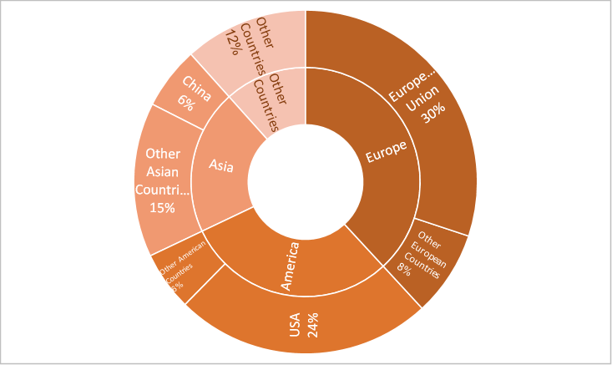
Imports of Goods (excl. Diamonds) by Country Group – 2023
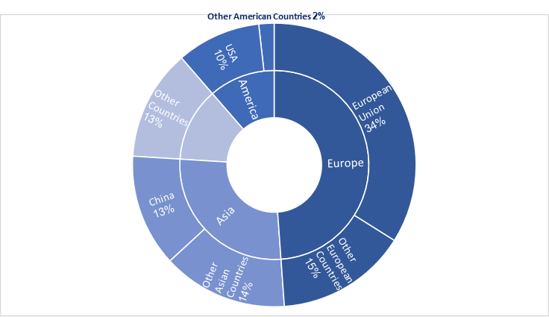

Trade in diamonds
In 2023, exports of diamonds (gross) totaled NIS 26.4 billion, a decrease of 27.7% compared with 2022. The main export destinations for diamonds were USA (54%), Hong Kong (10%), Belgium (8%), Switzerland (5%), India (5%) and United Arab Emirates (4%).

Imports of diamonds (gross) totaled NIS 16.2 billion, a decrease of 23.1% compared with 2022. The main countries from which diamonds were imported were: Belgium (23%), India (20%), USA (15%), Hong Kong (13%) and United Arab Emirates (12%).

Trade by countries - October -December 2023
Exports of goods October - December 2023
The trend data shows that exports of goods (excluding ships, aircrafts and diamonds) decreased by 2.2% at an annual rate in October - December 2023, following a decrease of 5.2% in July - September 2023.
Trend data indicate that exports (excluding diamonds) to the European Countries decreased by 9.7% at an annual rate in October - December 2023, following a decrease of 11.5% in July - September 2023.
Trend data indicate that exports (excluding diamonds) to the EU Countries increased by 4.0%, at an annual rate in October - December 2023, following a decrease of 2.9% in July - September 2023.
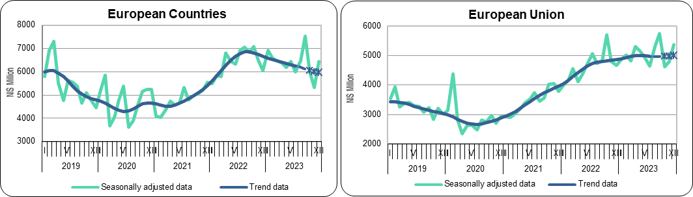

The last three trend estimates are subject to substantial revisions.
According to trend data, exports (excluding diamonds) to the Asian Countries increased by 6.6% in the last three months, at an annual rate, following an increase of 9.6% in July - September 2023.
Trend data indicate that exports (excluding diamonds) to China increased by 25.5%, at an annual rate in October - December 2023 (1.9% monthly average), following an increase of 20.3% in July - September 2023 (1.5% monthly average).
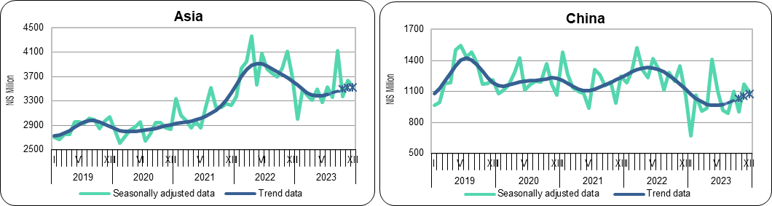

The last three trend estimates are subject to substantial revisions.
Trend data indicate that exports (excluding diamonds) to the American Countries increased by 1.2%, at an annual rate in October - December 2023, following an increase of 6.0% in July - September 2023.

Trend data indicate that exports (excluding diamonds) to the USA increased by 10.1%, at an annual rate in October - December 2023, following an increase of 12.4% in July - September 2023.
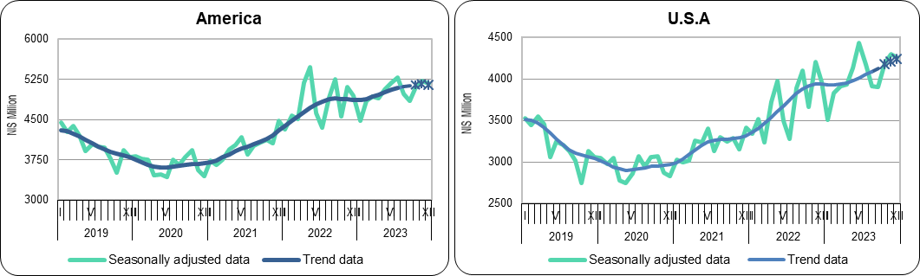
The last three trend estimates are subject to substantial revisions.
According to trend data, exports (excluding diamonds) to the Other Countries decreased by 16.5%, at an annual rate, in October - December 2023, following a decrease of 20.2% in July - September 2023 (1.9% monthly average).
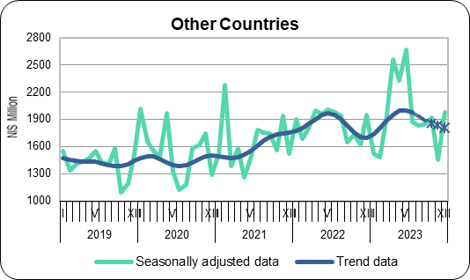
The last three trend estimates are subject to substantial revisions.
Imports of goods October - December 2023
According to trend data, imports of goods (excluding ships, aircrafts, diamonds and fuels) decreased by 13.9% at an annual rate, in October - December 2023, following a decrease of 10.1% in July - September 2023.
Trend data indicate that imports (excluding diamonds) from the European Countries decreased by 9.9% at an annual rate, in October - December 2023, following a decrease of 10.5% in July - September 2023.
Trend data indicate that imports (excluding diamonds) from the EU Countries decreased by 12.8%, at an annual, in October - December 2023, following a decrease of 10.3% in July - September 2023.

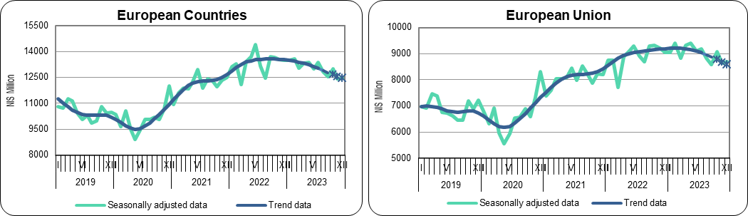
The last three trend estimates are subject to substantial revisions.
According to trend data, exports (excluding diamonds) to the Asian Countries decreased by 7.6% in the last three months, at an annual, following a decrease of 7.9% in July - September 2023.

Trend data indicate that imports (excluding diamonds) from China increased by 10.0% at an annual rate in October - December 2023, following an increase of 10.6% in July - September 2023.
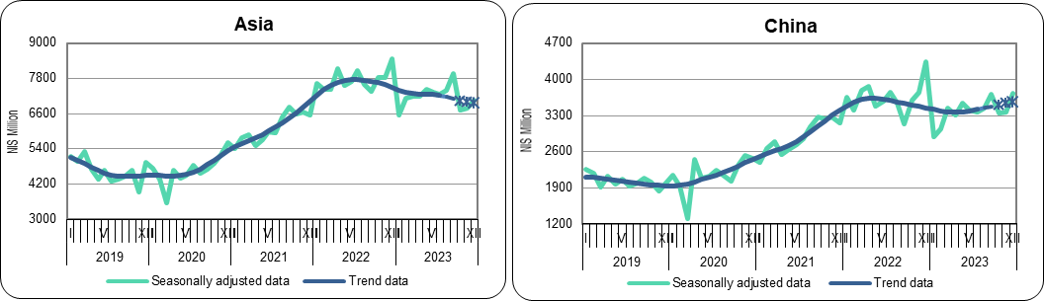
The last three trend estimates are subject to substantial revisions.
Trend data indicate that imports (excluding diamonds) from the American Countries increased by 6.2% at an annual rate in October - December 2023, following an increase of 6.9% in July - September 2023.
Trend data indicate that imports (excluding diamonds) from the USA increased by 4.8% at an annual rate in October - December 2023, following an increase of 6.2% in July - September 2023.

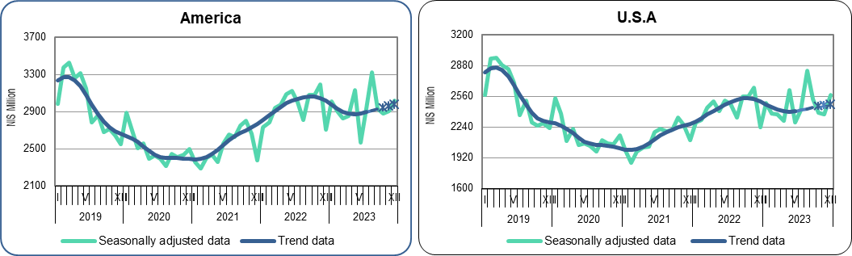
The last three trend estimates are subject to substantial revisions.
Trend data indicate that imports (excluding diamonds) from the Other Countries increased by 55.4% at an annual rate in the last three months (3.7% monthly average), following an increase of 31.1% in July - September 2023 (2.2% monthly average).
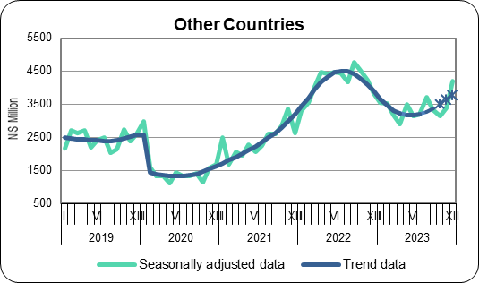
The last three trend estimates are subject to substantial revisions.
Next Press Release on “Israel’s Foreign Trade by Country” will appear on February 20, 2024.

The above is based on temporary data regarding goods that cleared customs, not including trade between Israel and the Palestinian Authority. In addition, the data do not include imports and exports of services (e.g. software). Data on all exports and imports of goods and services are published as part of the Balance of Payments, every quarter. 2023 data are provisional. Final data for 2023 will be released April 2024.
The seasonally adjusted data are calculated by adjusting the original data for the influence of seasonality and festival and trading day effects. Trend data are estimated by removing the irregular influences (noise) from the seasonally adjusted data. The seasonally adjusted data and the trend are subject to revisions as they are calculated anew, each month or quarter, on the basis of original data that include an additional observation (concurrent season adjustment).

