______________________________________________________________________________
Jerusalem
December 21, 2021
432/2021

Christmas 2021 - Christians in Israel
- On the eve of Christmas 2021, approximately 182,000 Christians live in Israel; they comprise about 1.9% of the State of Israel’s population. The Christian population grew by 1.4% in 2020.
- 76.7% of the Christians in Israel are Arab Christians. They constitute 7.0% of the total Arab population of Israel.
- Most of the Arab Christians reside in the Northern District (70.3%) and in the Haifa District (13.5%).
- 41.7% of the non-Arab Christians reside in the Tel Aviv and Central Districts, as compared to 34.2% in the Northern and Haifa Districts.
- The localities with the largest Arab Christian populations are Nazareth (21,400), Haifa (16,500), Jerusalem (12,900), and Shefar'am (10,400), as of the end of 2020.
- 803 Christian couples married in Israel in 2019. The average age at the first marriage of Christian grooms was 30.3, and that of Christian brides was 26.7.
- In 2020, 2,497 infants were born to Christian women, about 72% of whom (1,797 infants) were born to Arab Christian women.
- The average number of children up to age 17 in Christian families with children up to this age is 1.93. Of these Christian families, the average number of children up to age 17 in Arab Christian families is 2.04 – smaller than the numbers in Jewish families (2.43) and in Moslem families (2.60).
- In the 2020/21 school year, 27,044 Christian students – 1.4% of the total number of students – attended primary and secondary schools.
- 81.6% of Christian 12th-grade students were eligible for a matriculation certificate.
- 53.1% of the Arab Christians continued their studies toward a first degree within eight years of graduating high school, compared to only 35.4% of the total number of high-school graduates in the Arab school system and 47.2% in the Hebrew education.
- The proportion of women among the Christian students was higher than women’s proportion among the total number of students in all degrees and particularly in the advanced degrees: 64.1% and 53.2%, respectively, of those studying for a third degree, and 72.9% and 63.8%, respectively, of those studying for a second degree.
- Compared with Arab-Moslem students, the percentage of Christian-Arab students studying for a first degree (bachelor's degree) was lower in the following fields of study: Business and management sciences, Languages, literature and regional studies, as well as Paramedical studies. In contrast, the percentage of those who studied Engineering and architecture, Art, crafts and applied arts, as well as Medicine was higher.
- Of all students who were studying for a first degree, representation among the Christian students was highest in the following subjects of study: musicology (15.1%), management information systems (12.4%), and transportation engineering (11.2%).
- The percentage of participation in the labour force in 2020 among Christians aged 15 and over was 64.6% (68.2% of men and 61.9% of women). This figure was 53.7% among Christian Arabs (62.3% of men and 45.2% of women).
- Approximately 17,500 Christians – a rate of 98 per 1,000 persons – were registered at the Ministry of Labor, Welfare, and Social Services in 2020. This percentage was lower than that of Moslems who were registered (approximately 183 per 1,000 persons) and Jews who were registered (107 per 1,000 persons).
- In 2020, about 3,500 Christians – a rate of about 20 per 1,000 persons – were placed in social service frameworks. This rate is lower than the rate among Moslems (about 32 per 1,000 persons) and Jews (about 28 per 1,000 persons).
- In the year of court judgement 2019, the rate of persons judged in criminal trials among the Christian population in Israel was about 211 per 100,000 persons, out of those judged, the rate among non-Arab Christians was substantially higher than the rate among Arab Christians (about 293 and 187 per 100,000 persons, respectively).
- The rate of convicted Christians was about 187 per 100,000 persons. The rate of non-Arab Christian persons convicted was substantially higher than the rate of Arab Christians (about 259 and about 166 per 100,000 persons, respectively).
- The most common offences among persons convicted from the Christian population in Israel are as follows: offences against public order (27.4%), morality offences (19.7%), and bodily harm (16.4%).
- 84% were satisfied with their lives: 24% were very satisfied and 60% were satisfied.

Selected Data on the Christian Population (end of 2020)
At the end of 2020, there were approximately 180,000 Christians living in Israel, comprising 1.9% of the total population in Israel: 76.7% of the Christian population in Israel (137,600) were Arab Christians, comprising 7.0% of the total Arab population in Israel.
Of the Christian population in Israel, 23.3% (41,900) were non-Arab Christians. Most of them (including their children who were born in Israel) immigrated to the country with their Jewish family members under the Law of Return during the 1990s.
The growth rate of the overall Christian population was 1.4% in 2020. By way of comparison, the growth rate of the Jewish population was 1.5%, and that of the Moslem population was 2.2%. During the course of 2020, the Christian population grew by 2,392 persons, of whom 1,028 were added as a result of natural increase. Another 1,257 Christians were added to the Israeli population in the international migration balance, compared to 1,425 in the previous year.
Diagram 1 - The Christian Population of Israel, 1950–2020 (1)
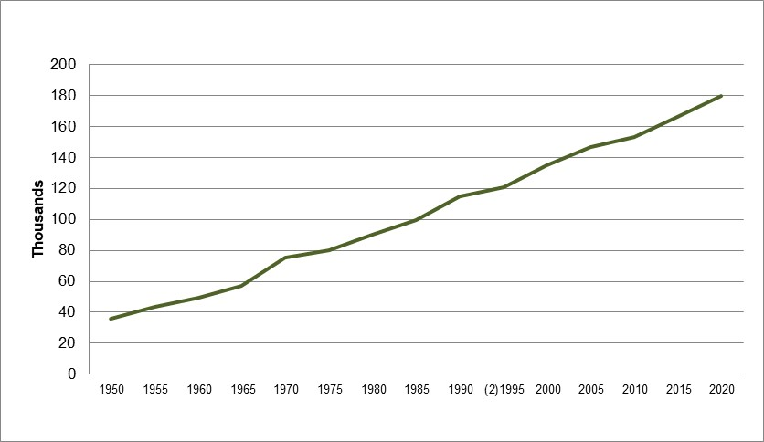
- Until 1994, the Christian population also included persons who were not classified by religion in the Population Register. Between 1990 and 1994, the population of persons who were thus unclassified was relatively large, and included the immigrants from the USSR (former).
- The figure is based on the census for that year.

Table A - The Sources of Growth in the Christian Population, 2020
Distribution of the Christian population | Natural increase, absolute numbers | International migration balance,  absolute numbers | Percentage of migration balance out of total growth | Percentage of annual increase
Total Christians | 1,028 | 1,257 | 52.5 | 1.4
Arab Christians | 941 | 33 | 3.1 | 0.8
Non-Arab Christians | 87 | 1,224 | 93.1 | 3.2
The Arab Christian population grew by 0.8% in 2020, primarily as a result of natural increase. By contrast, the non-Arab Christian population grew by 3.2%, primarily as a result of international migration.
The origin of the growth is due in part to natural increase and in part to the migration balance. In the last two years we have witnessed that the share of the migration balance is larger than in previous years. (In 2019 and 2020, the share of the migration balance in the total increase was about 53%).
Diagram 2 - Sources of Increase of the Christian Population Over the Past Decade
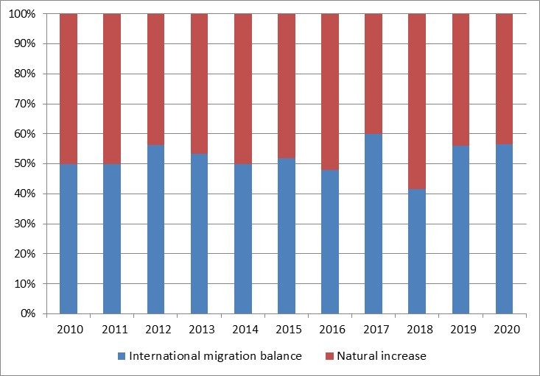
The age composition of the total Christian population is different from that of the Jewish and Moslem populations. The percentage of young people aged 0–19 was 26.0%, lower than that of the Jewish population (34.9%), and still lower than that of the Moslem population (43.8%).
Persons aged 65 and over made up 12.5% of the total Christian population, compared to 14.2% of the Jewish population and 4.5% among the Moslem population.
Diagram 3 - Age Structure of Christians, Jews, and Moslems, End of 2020
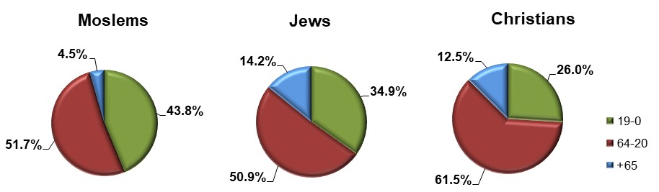

Geographic Distribution
Most of the Arab Christians lived in the north: 70.3% lived in the Northern District and 13.5% in the Haifa District. 9.4% lived in the Jerusalem District. As of the end of 2020, the localities with the largest Arab Christian population were Nazareth (21,400), Haifa (16,500), Jerusalem (12,900), and Shefar’am (10,400).
The geographic distribution of non-Arab Christians was different than that of Arab Christians: 40.7% lived in the Tel Aviv and Central Districts, and 34.1% lived in the Northern and Haifa Districts.
Large communities of non-Arab Christians were concentrated in the three large cities: Haifa (4,000), Tel Aviv-Yafo (3,900), and Jerusalem (3,400).

Diagram 4 - Population Distribution of Christians by District, End of 2020
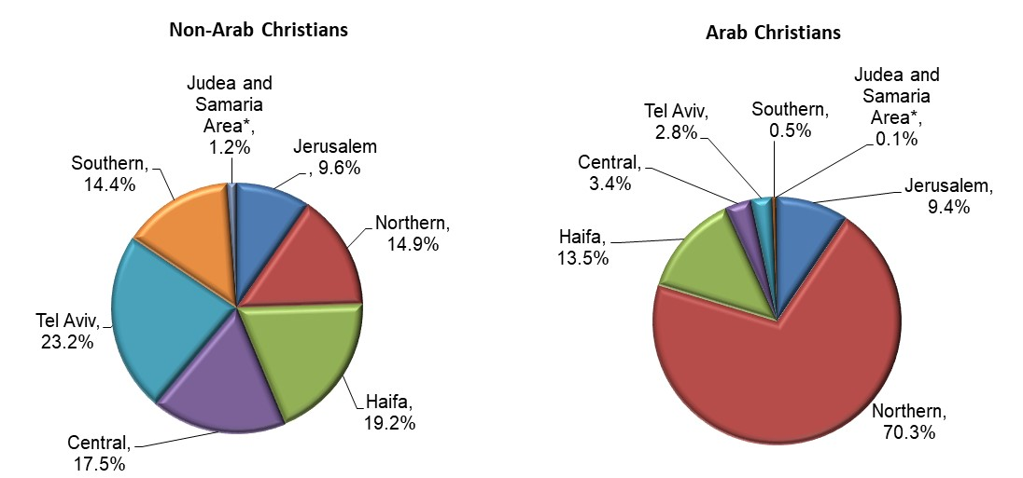
* Israeli localities only.
Table B – The Ten Localities With the Largest Christian Population Concentration, 2020
Locality | The Christian population (thousands)
Nazareth | 21.4
Haifa | 20.5
Jerusalem | 16.3
Shefar’am | 10.4
Nof HaGalil | 8.7
Tel Aviv-Yafo | 7.5
I'billin | 5.7
Kafa Yasif | 5.4
Mughar | 4.9
Eilabun | 4.1

Marriage and Fertility
In 2019, 803 Christian couples married in Israel; 89% of the grooms and 89% of the brides were Arab Christians.
The average age of Christian grooms marrying for the first time in 2019 was 30.3, older than the other groups. The average age of Christian brides marrying for the first time was also higher than that of the other groups: 26.7.
Diagram 5 - Average Age at First Marriage, by Religion and Sex, 2019
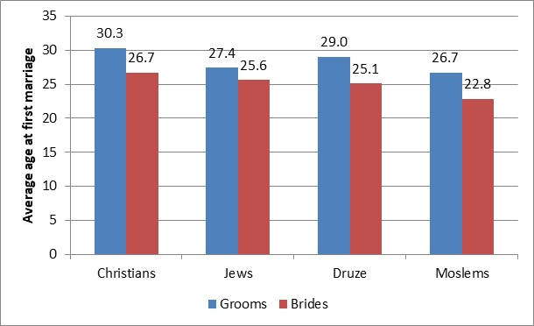
In 2020, 2,497 infants were born to Christian women; approximately 72% of them (1,797 infants) were born to Arab Christian women.
Out of 700 infants born to non-Arab Christian women, approximately 40% were born to women born in the USSR (former), approximately 18% to women born in Ethiopia, approximately 9% to women born in Israel, approximately 6% to women born in the Philippines, and approximately 3% to women born in Romania and in Germany.
In 2020, the number of children a Christian woman was expected to bear during the course of her lifetime (the total fertility rate) was 1.85 children per woman, 1.80 in 2019. The number of children per Arab Christian woman was lower still, at 1.74 children per woman. By way of comparison, a Jewish woman was expected to bear 3.00 children during her lifetime, a Moslem woman 2.99, and a Druze woman 1.94.

Households and Families
In 2020, approximately 63,000 households – 2.3% of all households in Israel – were headed by a Christian. Of these households, approximately 41,000 were Arab Christian.
The average size of a household headed by a Christian was 3.04 persons – slightly lower than the size of households headed by a Jew (3.07), and still lower than the size of households headed by a Moslem (4.53).
In approximately 65% of the households headed by a Christian, the head of the household was an Arab Christian. The average size of these households was 3.35 persons.
Of Christian households, approximately 77% (approximately 49,000) were “family” households (which include at least one family). This was similar to the percentage of Jewish family households, as compared with 93% among the Moslems.
Non-family households, which include one person only or a group of persons who are not a family, comprised approximately 23% of the Christian households. This was similar to the percentage among Jewish households, and higher than the percentage among Moslem households, which was only about 7%.
Approximately 7% of the households headed by a Christian consisted of 6 or more persons, slightly less than among households headed by a Jew (about 9%), compared to approximately 29% of the households headed by a Moslem.
There were approximately 51,000 Christian families in Israel. The distribution of Christian families by type of family differed from that among Jewish families, and differed even more from that among Moslem families.
Diagram 6 - Families by Type of Family: Jews, Moslems, and Christians, 2020
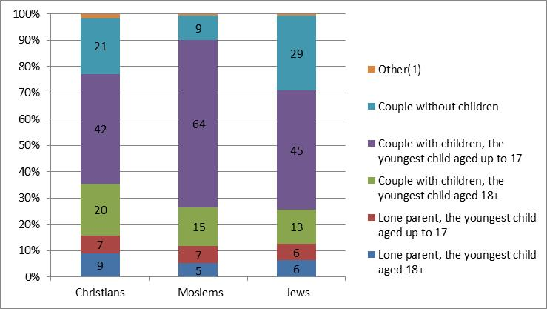
- Incl. families of siblings who live together, without spouses and without children; and a grandparent with grandchildren, without the children’s parents.; the range of data is 1%-2%.
The average number of children up to age 17 in Christian families with children up to that age was 1.93. Of these Christian families, the average number in Arab Christian families was 2.04. These figures are lower compared to Jewish families (2.43) and compared to Moslem families (2.60).

Education

Students in the Education System (School Year 2020/21)
In the 2020/21 school year, there were 27,044 Christian students in primary and secondary school, comprising 1.4% of all primary and secondary school students. This percentage was the same as in the school year 2019/20 (1.5%).
The vast majority (85.9%) of these students were Arab. Christian students comprised approximately 5% of the students in Arab education.
That same year, there were 1,903 Christian students in first grade (Arab education) – approximately 5% of all first-graders in Arab education.
Among Christian upper secondary education students (Arab education), 42.6% studied in a technological/vocational track. This figure was slightly higher than the percentage among Moslems (40.6%), and considerably higher than the percentage among Jewish upper secondary students (Hebrew education), which was 35.3%.
Diagram 7 - Students in Upper Secondary Schools Who Studied in Technological/Vocational Tracks, by Religion and Sex, 2020/21
Percentage of each group
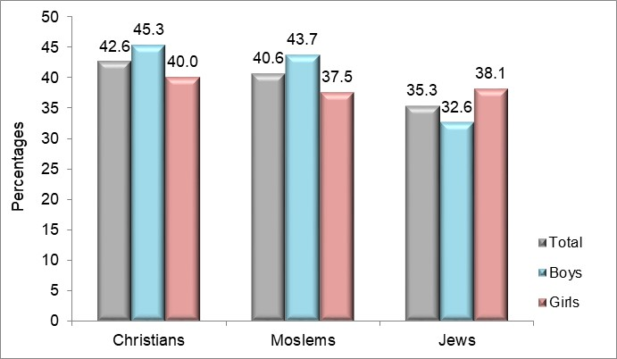

Matriculation Exams (2019/20)
In the 2019/20 school year, Christians comprised 6.1% of all 12th-grade students in Arab education.
In recent years, an increase has been observed in the rate of those eligible for a matriculation certificate; in this year, this increase was maintained and 81.6% of Christian students in 12th grade were eligible. The percentage of Christian students eligible for a matriculation certificate in 2019/20 was lower than the percentage in Hebrew education (83.4%) and lower than the percentage of Druze (88.5%), but higher than the percentage of Moslems (65%).
A high percentage of Christian Arabs students (71.7%) received a matriculation certificate that meets university entrance requirements (and who were thus potential candidates for continuing to higher education). The percentage was similar among students in Hebrew education (73.1%),and higher than the percentage of Druze (67.4%) and Moslems (47.3%) who were awarded the certificate.

Going on to Study for a First Degree Among Christian Upper Secondary School Graduates in 2011/12 Within Eight Years of Graduating Upper Secondary School (Tracking Until 2019/20)

Arab Christians
Of the Arab Christians, 53.1% went on to study for a first degree within eight years of graduation from upper secondary school, compared to only 34.0% of all upper secondary school graduates in Arab education.
The percentage of Arab Christians who attended universities, of the total number of Arab Christians who went on to study for a first degree, was much higher than the percentage of students in Arab education who went on to study for a first degree at the universities (44.8% and 32.3%, respectively). The percentage of Arab Christians who went on to study for a first degree at the academic colleges was slightly higher than the percentage of all students in Arab education (35.9% and 31.8%, respectively). The percentage of Arab Christians who went on to study for a first degree at the Open University was much lower than the percentage of all the students in Arab education (10.9% and 19.3%, respectively).
A small percentage of Arab Christian students chose to continue their studies at the academic colleges of education – 8.4% compared to 16.7% of the total number of students in Arab education.

Non-Arab Christians
Only 35.4% of the non-Arab Christians went on to study for a first degree within eight years of graduating high school, compared to 47.2% of all high-school graduates in Hebrew education.
The percentage of non-Arab Christians who attended universities, out of the total number of non-Arab Christians who went on to study for a first degree, was slightly lower than the parallel percentage of the total number of students in Hebrew education (33.3% and 34.6%, respectively). The percentage of non-Arab Christians who went on to study for a first degree in the academic colleges was also slightly lower than the percentage of all students in Hebrew education (38.1% and 40.9%, respectively). The percentage of non-Arab Christians who went on to study for a first degree at the Open University was substantially higher than the percentage of all the students in Hebrew education (20.6% and 11.9%, respectively).
A particularly low percentage of the non-Arab Christian students chose to continue their studies in the academic colleges of education – 7.9%, compared with 12.5% of the total number of students in Hebrew education.
Table C - Persons Who Go on to Study for a First Degree Among All Upper Secondary School Graduates and Among Christian Upper Secondary School Graduates (Arab and Non-Arab Christians) Within Eight Years after Completing School (2011/12), by Type of Institution
- | Hebrew Education, Total | Arab Education, Total | Arab Christians | Non-Arab Christians
Total Number of Upper Secondary School Graduates (absolute numbers) | 76,756 | 20,733 | 1,800 | 178
Of them:  Continued to academic studies (percentages) | 47.2 | 34.0 | 53.1 | 35.4
Continued to academic studies, by type of institution (percentages) | 100.0 | 100.0 | 100.0 | 100.0
Universities | 34.6 | 32.3 | 44.8 | 33.3
The Open University | 11.9 | 19.3 | 10.9 | 20.6
Academic colleges | 40.9 | 31.8 | 35.9 | 38.1
Academic colleges of education | 12.5 | 16.7 | 8.4 | 7.9

Students in 2020/21
In 2020/21, there were 6,900 Christian students, who comprised 2.3% of the total students at all the institutions of higher education in Israel – slightly more than their share of the population (about 2%). Among Christian students, 95.0% (6,600 students) were Arabs and 5.0% (350 students) were non-Arab Christians.
Among the Christian students, 71.7% were studying for a first degree, of whom 21.9% were in their first year (and 49.8% were in the other years); 22.1% were studying for a second degree, and 3.9% were studying for a third degree. Christian students comprised 2.3% of the total number of students studying for a first degree, 2.3% of the total students studying for a second degree, and 2.2% of the total students studying for a third degree.

Of the Christian students, 50.7% studied at universities, 39.1% studied at academic colleges (23.1% at budgeted colleges and 16.0% at non-budgeted colleges) and 10.2% studied at academic colleges of education.
Christian students comprised 2.6% of all university students, and 2.2% of the students at the academic colleges (2.3% at budgeted colleges, and 2.1% at non-budgeted colleges), and 1.7% of all students at academic colleges of education.
Compared with Arab-Moslem students, the percentage of Arab Christian students studying for a first degree was lower in the following fields of study: Business and management sciences, Languages, literature and regional studies, as well as Paramedical studies. In contrast, the percentage of those who studied Engineering and architecture, Art, crafts and applied arts, as well as Medicine was higher.

Table D - Distribution of Christian Arab Students Studying for Their First Degree, by Field of Study and Selected Religion and Population Groups (2020/21)
Field of Study/Population Group | Total | Total Christians | Thereof: Arab Christians | Arab Moslems
Total (absolute numbers) | 211,598 | 4,956 | 4,704 | 31,700
Percentages | 100.0 | 100.0 | 100.0 | 100.0
General humanities | 2.7 | 2.1 | 1.9 | 1.8
Languages, literature and regional studies | 1.4 | 1.9 | 1.8 | 2.1
Education and teacher training | 16.3 | 10.3 | 10.6 | 25.8
Arts, crafts, and applied art | 3.7 | 4.4 | 4.3 | 2.2
Social sciences | 17.1 | 14.6 | 14.5 | 13.5
Business and management sciences | 11.3 | 10.6 | 10.5 | 14.6
Law | 6.9 | 9.4 | 9.5 | 5.4
Medicine | 1.0 | 1.5 | 1.4 | 0.5
Paramedical studies | 6.7 | 9.0 | 9.0 | 10.2
Mathematics, Statistics, and Computer sciences | 9.4 | 9.9 | 9.9 | 6.7
Physical sciences | 1.3 | 0.7 | 0.7 | 1.0
Biological sciences and agriculture | 3.4 | 3.8 | 3.8 | 3.1
Engineering and architecture | 18.8 | 21.8 | 22.2 | 13.0
Of all students who were studying for a first degree, representation among the Christian students was highest in the following subjects of study: musicology (15.1%), management information systems (12.4%), and transportation engineering (11.2%).

Diagram 8 - Subjects of Study That Had a Higher Percentage of Christian Students (Percentage of Christians Out of the Total Number of Students in Each Subject), 2020/21
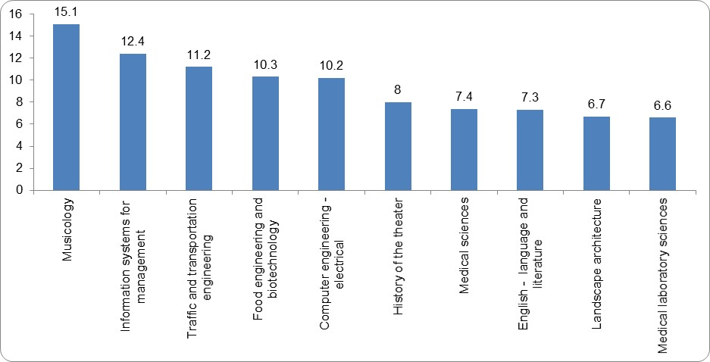
The share of women among the Christian students was higher than it was among the total number of students, for all degrees and particularly among those studying for advanced degrees.
Table E - Percentage of Women among the Christian Students and Among the Total Number of Students, By Degree (2020/21)
Degree | Among Christian students | Among all students
Total (including diplomas) | 61.8 | 59.8
First degree | 57.5 | 58.3
Second degree | 72.9 | 63.8
Third degree | 64.1 | 53.2

Students at the Open University in 2020/21
In 2020/21, there were 700 Christian students at the Open University; they comprsie 1.3% of the total number of students there, less than their share in the general population (about 2%); 80.3% of the Christian students were Arabs (600 students). of all Christian students 92.8% studied for a first degree, 5.5% studied towards a second degree and 1.7% studied towards an academic diploma.
For a first degree, Christian students studied more social sciences than non-Christian students (66.3% versus 59.7%, respectively) and less mathematics, statistics and computer science (10.2% versus to 13.5%, respectively).

Employment
The percentage of participation in the labour force among Christians aged 15 and over in 2020 was 64.6% (68.2% among men and 61.9% among women). Among Arab Christians, this figure was 53.7% (62.3% among men and 45.2% among women). By comparison, the percentage of participation in the labour force among Jews aged 15 and over in 2020 was 66.5% (68.1% among Jewish men, and 64.9% among Jewish women).
The employment rate (percentage of employed persons out of all persons aged 15 and over) among Christians aged 15 and over was 62.2% (65.4% among men, and 59.8% among women). The employment rate among Arab Christians was 51.6% (60.1% among men and 43.1% among women). By comparison, the employment rate among Jews aged 15 and over was 63.5% (64.9% among Jewish men and 62.1% among Jewish women).
The percentage of unemployed persons among Christians aged 15 and over was 3.7% (4.2% among men and 3.3% among women). This figure among Arab Christians was 4.0% (3.5% among men and 4.6% among women). By comparison, the percentage of unemployed persons among Jews aged 15 and over was 4.5% (4.8% among men and 4.2% among women).
In 47,900 Christian households (75.5% of all Christian households), there was at least one employed person (in 19,100 households there was only one employed person, and in 28,800 households there were two or more employed persons). In 30,600 Arab Christian households (74.1% of all Arab Christian households) there was at least one employed person (in 11,700 households there was only one employed person, and in 18,800 households there were two or more employed persons). By comparison, in 1,747,000 Jewish households (78.9% of all Jewish households), there was at least one employed person (in 696,500 households there was only one employed person, and in 1,051,500 households there were two or more employed persons).
The housing density of Christian households was 0.96 persons per room (1.01 persons per room in Arab Christian households). By comparison, the housing density of Jewish households was 0.79 persons per room.

Christians Aged 20 and Over — 2020 Social Survey Data
- 84% were satisfied with their lives: 24% were very satisfied and 60% were satisfied.
- 46% of Christians are optimistic and estimate that their lives in the coming years will be better.
- 47% estimate that their health is 'very good', another 34% — that their health is 'good'.
- 59% of the Christians were satisfied with their economic situation; 74% succeed in covering the monthly household expenses for food, electricity, telephone, etc.
- 91% of Christian employed persons are satisfied with their work, 68% are satisfied with their income from work.
- 58% of Christians have a 'good' or 'very good' level of speaking Hebrew, 23% have a medium level. The rest (19%) speak Hebrew with difficulty or do not know how to speak Hebrew at all.
- 93% of Christians use the Internet.
- 31% of Christians shop online; one-third (33%) used the Internet to obtain services from government ministries, such as downloading or filling out forms, obtaining permits and certificates (in the three months prior to the interview).

Welfare

Persons Registered at the Ministry of Welfare and Social Affairs and Persons Defined as Needing Intervention
In 2020, about 17,500 Christians – about 98 per 1,000 persons – were registered at the Ministry of Welfare and Social Affairs. The rate of persons registered among the Christians was lower than among Moslems (about 183 per 1,000 persons) and Jews (107 per 1,000 persons).
Of the Christians who were registered, about 57% were women and about 43% were men. About half of those registered (about 49%) were married, about 30% had never been married, and the rest were widowed (about 15%) or divorced (about 6%).
About 81% of the Christians who were registered (about 14,100) were defined as needing intervention. This rate is about 79 per 1,000 persons. Like the rate of registered persons, the rate of persons defined as needing intervention among the Christian population was lower than among Moslems (125 per 1,000 persons) and Jews (about 70 per 1,000 persons).
The most prevalent type of intervention among Christians who were defined as needing intervention was dysfunctional parents and/or children/adolescents (about 30%). The next most prevalent types of intervention needed were geriatric, medical reasons and disability (about 22% for each one of them).The least prevalent type of intervention needed was addiction and delinquency (about 2.3%).

Recipients of Social Services in Community and Out-of-Home Frameworks of the Ministry Welfare and Social Affairs
In 2020, about 3,500 Christians – a rate of about 20 per 1,000 persons – were placed in social service frameworks. This rate is lower than the rate among Moslems (about 32 per 1,000 persons) and Jews (about 28 per 1,000 persons).
Most of the Christians who were placed in social service frameworks (about 84%, about 17 per 1,000 persons) were placed in community frameworks only. In contrast, about 12% (about 2.3 per 1,000 persons) were placed in out-of-home frameworks only, and about 4% (about 0.8 per 1,000 persons) were placed in both community frameworks and out-of-home frameworks. This breakdown is different from the breakdowns of Jews and Moslems who were placed in social service settings (see Diagram 9).
Diagram 9 - Persons Placed in Social Service Frameworks, by Religion and Type of Framework, 2020
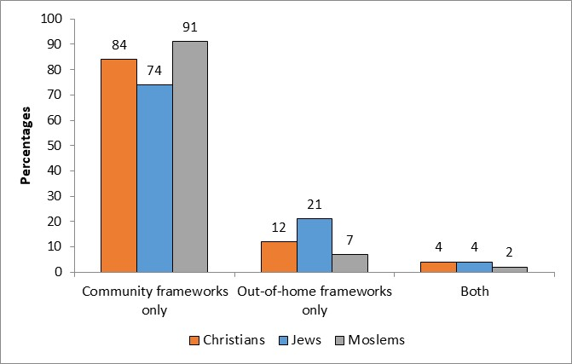

Crime and Justice, Court Judgement 2019
In the year of court judgement 2019, the rate of persons judged in criminal trials among the Christian population in Israel was about 211 per 100,000 persons, considerably lower than the rate among Moslems (about 458 per 100,000 persons) and similar to the rate among Jews (about 212 per 100,000 persons).
Of those judged in criminal trials among the Christian population, the proportion of men was 413 per 100,000 persons. Of those, the rate of non-Arab Christian men was about 769 per 100,000 persons, compared with the rate of Arab Christian men, about 326 per 100,000 persons. A similar trend was observed among women. The rate of women judged in criminal trials was 35 per 100,000 persons: about 53 per 100,000 persons among non-Arab Christian women and about 29 per 100,000 persons among Arab Christian women.
As mentioned, the rate of men judged in criminal trials among the Christian population was about 413 per 100,000 persons, similar to the rate of Jews but substantially lower than the rate among Moslems (about 416 and about 888 per 100,000 persons, respectively). The rate of women judged in criminal trials among the Christian population was about 35 per 100,000 persons, lower than both the rate of persons judged in criminal trials among Jews and the rate of persons judged in criminal trials among Moslems (about 51 and about 49 per 100,000 persons, respectively).

Convicted Persons
The rate of convicted Christians (about 187 per 100,000 persons) is slightly higher than the rate of convicted persons among Jews (about 175 per 100,000 persons) and considerably lower than the rate among Moslems (about 420 per 100,000 persons).
Diagram 10 - Persons Judged in Criminal Trials among Israel’s Population, by Religion and by Verdict, Year of Court Judgement 2019
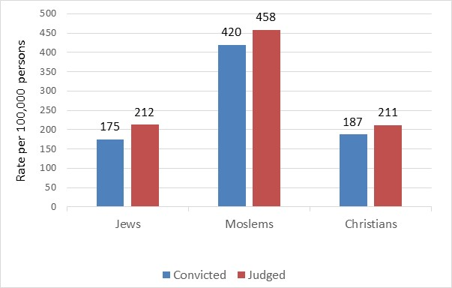
In the year of court judgement 2019, the rate of non-Arab Christian persons convicted was substantially higher than the rate of Arab Christians (about 259 and about 166 per 100,000 persons, respectively).
Diagram 11 – Persons Judged in Criminal Trials among the Christian Population, by Verdict, Year of Court Judgement 2019
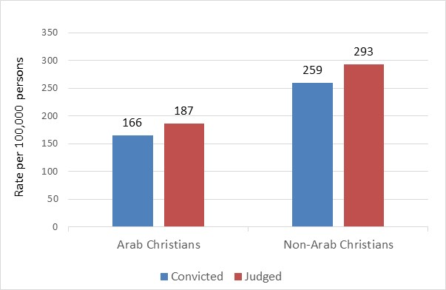
In an examination by sex, the rate of convicted men among the Christian population was about 364 per 100,000 persons. This rate is similar to the rate of Jews (about 343 per 100,000 persons), but significantly lower than the rate among Moslems (about 805 per 100,000 persons).
The rate of convicted women among the Christian population was about 25 per 100,000 persons. This rate is lower than both the conviction rate among Jews and the conviction rate among Moslems (about 39 and about 42 per 100,000 persons, respectively).
Recidivists and Common Offences
In the year of court judgement 2019, 53.3% of those convicted among the Christian population in Israel were recidivists (52.4% among Arab Christians and 55.1% among non-Arab Christians) compared with 56.4% among all residents of Israel.
In examining the distribution of offence groups, the most common offences among persons convicted from the Christian population in Israel are as follows: offences against public order (22.8%), bodily harm (18.6%), morality offences (15.3%) and property offences (15.3%). The least common offences among the Christian population are sexual offences (2.7%) and offences against the security of the state (2.1%).
Diagram 12 – Persons Convicted, by Offence Group, Year of Court Judgement 2019
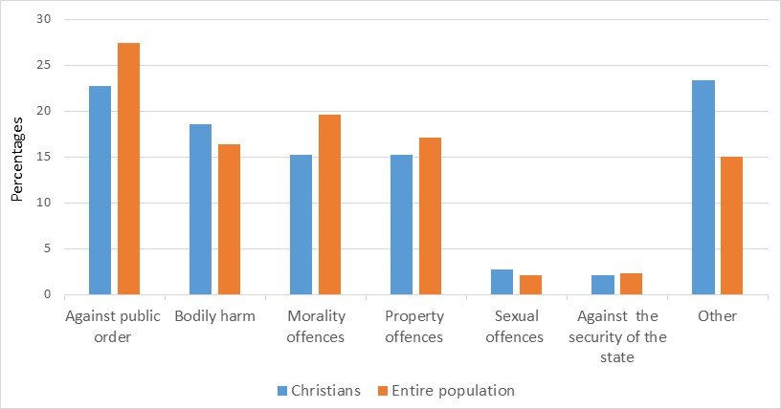

Definitions and Explanations - Crime

Sources of the data
Data based on Criminal Register of the Israel Police. This system was developed and is being managed by the Technological Administration of the Israel Police. The system is intended to manage the Criminal Register in accordance with principles established in the law, including rules governing the statute of limitations and erasure of information.
The Criminal Register documents and administers criminal offences, verdicts concerning those offences, and the penalties adjudicated for them.
Persons judged in criminal trials: The data present information on persons charged in criminal trials who were handed a verdict in a given year. The data relates to residents of Israel who were charged with a criminal offence, as well as foreign residents and residents of the Palestinian Authority who committed crimes against Israelis or crimes in Israel’s territory. This Media Release focuses only on residents of Israel.
The data include verdicts reached in courts of first instance including: district courts, magistrates' courts, special courts (traffic courts, juvenile courts, municipal courts, family courts, and small claims courts), as well as in military, administrative, religious, and labour tribunals. The data do not include cases that were closed/withdrawn by the state attorney's office or by the police due to administrative and other decisions, in which a verdict was not given.
The counting unit is a court judgement concerning a single person, in which each judgement may relate to one court case or more. A court case can include charges against a person for more than one offence.
Each court judgement is counted once, even if it relates to several criminal cases or incidents that occurred at different times and places. When a court judgement relates to more than one case (consolidated cases), the data relate to the main case. When a single person was the subject of several verdicts during a given year, that person is represented only once. Such persons are represented by the last verdict given during the reference year.
Conviction/convicted persons: A conviction is considered any case in which the court finds persons guilty of the charges against them (excluding quashed convictions).
A verdict can be presented according to several levels of detail: at the level of the court judgement alone, at the level of the court case, at the level of an investigation file and at the level of the specific offence.
The calculated decision for a verdict is determined upwards from the level of the offence to the level of the court judgement. A calculated decision will be considered to be a conviction if there was a conviction at least at one of the levels. In all other cases, the decision will be recorded as a non-conviction.
Non-conviction: includes persons who were acquitted or acquitted on grounds of reasonable doubt. In addition, persons who were found unfit to stand trial or who were not criminally liable due to mental illness or mental disability, as well as convicted persons whose convictions were quashed are also included.
The procedure for quashing convictions refers to criminal trials in which before sentencing, the court imposed a probation order or a community service order while quashing the conviction - according to paragraph 192A of the criminal legal procedure act [integrated version] 1982.
Recidivists: Persons who had been convicted of two or more offences by the end of the reference year. Newly accused persons and newly convicted persons are those who by the end of the reference year had been convicted only once, even if that conviction was for more than one offence. Persons whose previous conviction was expunged from their record after they served their sentence are also considered new offenders.
Criminal offence: A criminal incident involving a violation of a paragraph of the law, for which a person was charged for committing an offence. In statistical analyses where the individual is represented by a single offence, the type of offence is determined by the most severe paragraph of the law for which the person was charged and convicted, by the maximum penalty that may be imposed by law, and based on the classification of criminal offences defined by the Israel Police.
Classification of offences according to the Israel Police classification:
Offences against the security of the state: Treason and espionage; rebellion and incitement to rebellion; offences against Emergency Laws; infiltration; transmitting state secrets.
Offences against the public order: Obstructing a public worker; assaulting or obstructing a police officer; altercations and disturbances on the streets or in institutions; threats; bribery; illegal gatherings and assembly; noise disturbances or road blocking; trespassing; offences against the Law of Entry into Israel.
Offences against a person’s life: Murder; attempted murder; manslaughter; negligence causing death; threats of murder or manslaughter.
Offences of bodily harm: Severe bodily injury; assault; kidnapping; coercion and false imprisonment.
Sexual offences: Rape; indecent acts; transmitting a STD; sexual harassment.
Offences against morality: Prostitution offences and drug offences.
Offences against property: Robbery; extortion; assault for the sake of theft; breaking and entering into businesses, institutions or dwellings; bicycle theft; car theft; pickpocketing; malicious cause of damage to property.
Fraud: Counterfeiting of documents or money; issuance of a check without sufficient funds.
Economic offences: Fiscal and economic offences.
Administrative offences: Municipal by-laws.
Licensing offences: Gun and ammunition licensing; work, manufacturing and business licensing; radio and television; traffic violations; illegal construction licensing offences.

This preliminary estimate for December 2021 does not include Christians who do not appear in the Population Register (foreigners).
Fields in which at least 100 students studied for a first degree are discussed.
Excluding the academic colleges of education. Students studying two fields were counted in each of their fields of study. Subjects studied for a first degree by 100 or more students are discussed.
Non-Arab Christians usually marry abroad.
Including infants born in Israel to Christian women who are not Israeli residents but whose spouses are Israeli residents.
A household is defined as one person or a group of persons living together in one dwelling on a permanent basis most of the week, who have a joint expense budget for food. They may be related or unrelated persons or a combination of persons both related and unrelated. A family household is a household that contains at least one family. A family household can include: one family, one family with "other persons", or two families or more. A family (a nuclear family) is defined as two or more persons who share the same household and are related to one another as a married or unmarried couple (including same-sex couples), or as parent and child (including an adopted child). The major types of families are a couple only, a couple with children (in various age groups, defined by the age of the youngest child), or a lone parent (a lone-parent family) with children. Other types of families that have been defined are: a grandparent with grandchildren, without the children’s parents; and siblings who live together, without spouses and without children. The data on households and families are based on the Labour Force Survey 2020. The data do not include persons living in institutions, kibbutzim, or student dormitories, or persons living outside localities (Bedouin in the South).
Beginning in the 2016/17 school year, the method of calculating technological/vocational education (formerly the technological track) was changed, and updated to reflect the current definitions of the Ministry of Education.
Until the school year of 2019/20, the calculation was made from the total of 12th grade students and did not include students in Arab education whose religion was unknown. As of the 2019/20 school year, the rate of those entitled to a matriculation certificate is calculated from the total number of 12th grade students, and the number of cases of unknown religion is negligible.
Not including students in schools under ultra-Orthodox supervision.
The Open University has characteristics that set it apart from other institutions of higher education. This is reflected in the admission processes of the students, in the course of their studies, in the composition of the student population, and more. At the end of this chapter there is a separate paragraph with the data of the Open University.
Fields in which at least 100 students studied for a first degree are discussed.
Excluding the academic colleges of education. Students studying two fields were counted in each of their fields of study. Subjects studied for a first degree by 100 or more students are discussed.
The data cited in this section were processed by the Central Bureau of Statistics on the basis of a file of basic data of the Ministry of Welfare and Social Affairs. The file includes statistics about families that are registered in the departments of social services.
A file is opened for every family or person who applies or is referred to social departments, and at least one family member must be defined as needing intervention.
Need for intervention: The reason why the individual applied, or was referred to, the social-services departments. The social worker who is working with the family indicates, for each person noted in the treatment file, his or her main area of neediness and that of his or her family, of a set list of 58 categories of need for intervention (including “normal” need for intervention). The social worker may also indicate a secondary category of neediness for the individual or for his or her family.
This need for intervention includes problems with the parent-child relationship, dysfunctional mother or father, children’s educational or behavioral problems, adolescent girls in distress, abandoned children, etc.
The data presented in this section were processed at the CBS on the basis of files of frameworks and names of the Ministry of Welfare and Social Affairs. The files include data on persons placed in out-of-home social service frameworks and in community frameworks.
Placed in the community framework refers to a person who continues to live with his natural family and receives community services and support in accordance with the "Looking Towards the Community" policy of the Ministry of Welfare and Social Affairs. Examples of community frameworks are: day care centers, after-school child care programs, day care in a home settings, parent and child centers, and centers for the prevention of violence.
Placed in an out-of-home framework refers to a person who is unable to live with his family due to his own exposure or exposure of his family to situations of distress and risk. Examples of out-of-home frameworks are: foster families, shelters, boarding schools, emergency centers, and nursing homes.
Recidivists are persons judged in criminal trials who have been convicted of two or more convictions by the end of the year under investigation. For more detailed information, see Definitions.

